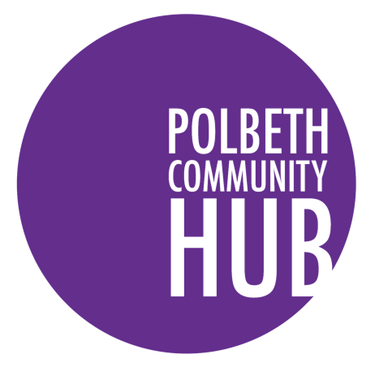

Polbeth Community HUB SCIO

Recruitment Pack

Trustee

Polbeth Village Hall, Polbeth, West Lothian, EH55 8SD

Registered Charity SC048906
Telephone No: 01506 536123 E-mail:hub@polbeth.org Web: www.polbeth.com
About us

Polbeth Community HUB SCIO (known as Polbeth Community Hub) is a Scottish Charitable Incorporated Organisation (SCIO) number SC048906 registered with the Scottish Charity Regulator (OSCR). For the purpose of this document the organisation will be referred to as Polbeth Community HUB.
The Objects as set out in Polbeth Community HUB’s governing document are:
- The provision of recreational facilities, or the organisation of recreational activities within the object of improving the conditions of life for the persons who the facilities or activities are primarily intended.
- The advancement of community development including the advancement of rural regeneration principally within the Community;
But only to the extent that the above purposes are consistent with furthering the achievement of sustainable development.
The Area of Benefit as set out in Polbeth Community HUB’s governing document and registered with the Scottish Charity Regulator is the community of Polbeth, West Lothian which comprises of the Polbeth Community Council boundary.
The Hub offers a wide range of activities, clubs, groups, services and more for the local community. Our core activity is to provide and deliver services and activity for the village. We do this by providing services from the community hub, by keeping people informed and by working with groups and individuals from our widder community.
We provides over 44 class per week within their building, ranging from Toddlers Group through to Highland Dancing and Yoga Class. These groups together with events and projects help to bring the local community together to increase skills, build relationships and support individuals and families who may be struggling through welfare reform.

Mission Statement
Polbeth Community HUB Mission is to be a sustainable, joined up HUB for the wider community which inspires and supports social change.
Value Base

The Values that Polbeth Community HUB work towards may be summarised as follows:

      - Reducing poverty – we will tackle poverty at a local level to reduce inequality and build a fairer and more inclusive community
- Increasing potential - We promote opportunities for individuals to increase their potential via training, activities and service which will support the growth of an individual.
- Inclusive -We positively welcome diversity of background, ethnicity, skills, talents and contributions from everyone.
- Caring - maintain respectful relations with customers, partners, suppliers, employees and communities
- Innovative - We embrace a culture for change that strives for continuous reflection, improvement and achievement of excellence.
- Inspirational - We promote imagination and positivity, motivating our staff and the local community.
- Circle economy – We will keep our local economy alive, by increasing our choices, and support small businesses that contribute to environmental sustainability.

The Role

Title: Trustee
Responsible to: Chair of Trustee
Hours: Board meetings are held on a monthly to six weekly basis, typically in the evening.
Salary: Voluntary but travel expenses paid
Duration: 1 years
Location: The Board meets in Polbeth or remotely by zoom.

Role Responsibilities

The Board are responsible for setting the strategic direction of the organisation to deliver the charitable objectives. As a member of the Board of Trustees you will be responsible for ensuring the effective oversight and governance within the organisation for the benefit of the vulnerable young people we support.
Polbeth Community HUB have an experienced management team who are responsible for the day-to-day management and service delivery of the organisation’s staff. The Board will be responsible for the supervision of the Manager to take overall responsibility for the organisation, acting collectively and effectively in its interests by giving strategic direction and determining our mission and vision. The Board make decisions required for assurance and management of the organisation, ensuring compliance, good governance and adequate financial resources for our services whilst protecting our assets and property. The Board also ensure we manage risks carefully, as a responsible employer and uphold the principles of equality and diversity.
General responsibilities, of the Board include:
- Promote and champion the values of Polbeth Community HUB.
- Provide strategic leadership, and support to the Manager
- Ensure that Polbeth Community HUB complies with its constitution, charity law, other relevant legislation or regulations
- Ensures that Polbeth Community HUB pursues its objects as defined in its constitution
- Ensure the financial viability and sustainability of the Charity
- Ensure that Polbeth Community HUB applies its resources exclusively in pursuance of its charitable objectives
- Design, review and approve all strategic policies, plans and budgets to ensure the organisation complies and delivers its charitable objectives, and monitor performance against them
- Set and maintain frameworks of delegation, internal control and risk management
- Ensure effective and efficient administration of the organisation and support Manager, as necessary
- Annually review the performance of the Board and take steps to improve its performance
- Appoint independent auditors
- Be aware of and abstain from any conflict of interest
- Keep beneficiaries at the heart of decision making
- Seek new Trustees when appropriate

Person Specification

Polbeth Community HUB are embarking on a transformation journey with the aim of enhancing our core service and expanding our Wellbeing service capability within our widder community. To complement the skills and experience already on the board, we are particularly interested in recruiting new board members with the following experience and skills:

- Business development
- Finance
- Marketing
- Service development

We are also keen to enhance the diversity of the board and would encourage applications from:

- Black, Asian and Minority Ethnic (BAME) background;
- Female;
- Under 50 years old;
- lived experienced and/ or experience of poverty.

Previous board experience is not essential but we would consider the following qualities and competencies to be essential:
- experience of working as part of a team;
- understanding of charity governance and duties of a charity trustee;
- non-judgemental and commitment to the strategic values of Polbeth Community HUB;
- leadership within your field of expertise;
- sound, independent judgement;
- ability to devote sufficient time and effort to Polbeth Community HUB.

How to apply

If you would like to help shape and develop an organisation committed to achieving our mission whilst supporting its values we would be delighted to hear from you.

Please download application, and email to hub@polbeth.org

We only accept fully completed application form; CV’s will not be accepted.

Interviews are likely to be held on zoom. If this will present a challenge for any reasons please let us know as soon as possible in order that we can make alternative arrangements.

If you would like to have an informal discussion prior to applying please contact:
Errin Anderson Manager errin@polbeth.org

We are an equal opportunities employer and we welcome applications from all suitably qualified persons.

