***Promoting, Supporting and Developing West Lothian’s***

***Voluntary Sector***

**Unincorporated Association**

Factsheet 1.2

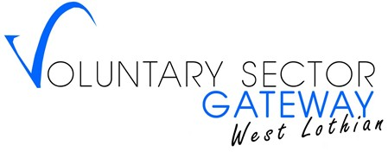

An unincorporated association is a voluntary organisation in its simplest form as it is quick to establish and, unless awarded charitable status, has no external regulator. However, as it is an unincorporated entity the management committee incur personal liability for its actions (please see section 1.1) so careful consideration should be given before selecting this structure.   
  
Traditionally unincorporated associations are membership organisations meaning that the members are responsible for electing from among themselves a management committee. In the case of unincorporated organisations with charitable status, the management committee members are the charity trustees. The key characteristics of an unincorporated association are detailed in the below table.

| **Key characteristics of an unincorporated association** | |
| --- | --- |
| Is this legal structure incorporated? | No. |
| Can this legal structure be a charity? | Yes, providing it can meet the charity test. |
| Who are the regulators? | An unincorporated association has no regulator unless it is a charity, in which case it will be regulated by the Office of the Scottish Charity Regulator (OSCR). |
| What is the key legislation? | No legislation applies unless the organisation is a charity, in which the Charities and Trustee Investment (Scotland) Act 2005 applies. |
| Is there a registration fee? | No. As an unincorporated association has no regulator, unless a charity, there is no fee. Applications for charitable status are also free of charge. |
| What type of governing document is required | Constitution. |
| What is the membership structure? | Unincorporated associations are typically membership organisations meaning that they have a two tier structure (governed by a committee who are elected by a membership). However, they can also have a single tier structure (governed by a committee with no additional members). |
| What are the annual reporting requirements? | An unincorporated association without charitable status does not have to report to any external regulator but should produce externally scrutinised accounts. With charitable status, it must submit to OSCR a Trustees’ Annual Report, completed Annual Return form and externally scrutinised accounts. |
| What are the accounting requirements? | Regardless if it has charitable status, providing its constitution doesn’t state that it should prepare accrued accounts an unincorporated association can prepare accounts on a receipts and payments basis. With charitable status, the income must also be under £250,000 to do so. |
| Are there any specific duties or requirements? | No specific duties or requirements other than those stated in the constitution. |