Whole Systems Approach to Type 2 Diabetes in Whitburn

This briefing is intended to provide you with information about a ‘whole systems’ pilot project planned for Whitburn and to invite you to take part in our online workshops on 27 and 28 April 2021 as a key stakeholder in the Whitburn community.
Whole Systems Pilot

This project is part of the East of Scotland (East Region) Prevention and Remission of Type 2 Diabetes Programme in partnership with the Scottish Government. The overall objective of the project is to identify actions and interventions across the ‘whole system’ that support people living in the community to maintain a healthy diet and weight, therefore reducing the occurrence of Type 2 Diabetes in the pilot area over the longer-term.

There is £60,000 of external grant funding being made available for this project, via an application process. Additional resources will be made available to each pilot and collectively in the East Region. However, local commitment and resource is also required and there is a strong emphasis on partnership working and joint responsibility across multiple partners and stakeholders.

The diagram below summarises what ‘whole systems’ approaches generally look to achieve:

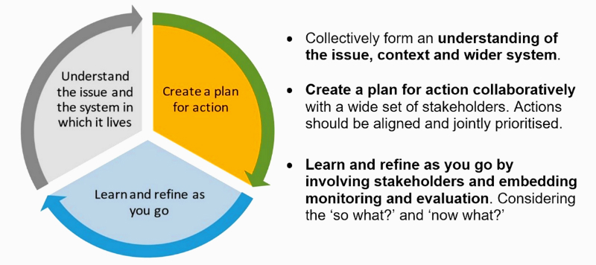

The specific aims of the project are to:
- Test a whole system approach to diet and healthy weight;
- Explore a wide range of levers and opportunities to influence local policies and partnerships to implement innovative approaches to addressing the problem and demonstrating what is possible within existing frameworks;
- Identify barriers to local action; generating learning which can be shared across Scotland; and potentially informing change to government policy.
Pilot projects will have the aim of increasing healthy weight across the local population with a focus on children and health inequalities.
The experience of the Whitburn pilot itself will also be used to inform the whole systems approach to dealing with public health issues which may also be used more generally within West Lothian in future.
Why focus on Type 2 Diabetes?

Obesity in Scotland has a strong link with inequalities. Lower socio-economic status is associated with higher levels of obesity and risk of obesity in children is lowest for those living in more affluent areas. Around 32% of adults living in the most deprived areas are obese, compared with 20% of those living in the least deprived areas. Women and children in the most deprived areas are particularly affected by more extreme obesity. The Scottish Public Health Observatory estimates that almost half of Type 2 Diabetes can be attributed to obesity: the risk of Type 2 Diabetes is around ten times higher among those with a BMI over 30 compared to those with a BMI under 30.

Obesity in childhood is linked to obesity later in life and poor health outcomes as an adult. Children who are at risk of obesity are twice as likely to develop Type 2 Diabetes and children living in deprived areas are more at risk of being overweight than those living in more affluent areas.

Why choose Whitburn?

Careful consideration was given to where the pilot should take place and the choice needed to be justified as part of the application process. Whitburn was ultimately thought to be an appropriate area to run the pilot for the reasons below.

Whitburn is characterised by underlying poverty and income deprivation and an older population than the West Lothian average. There is also a higher incidence of poor health in Whitburn than in West Lothian in general.

The most deprived ‘intermediate’ area in Whitburn, Whitburn Central, compares as worse than the Scottish average and the West Lothian average for the following associated indicators:

- Maternal obesity (2nd worst in West Lothian)
- Babies exclusively breastfed at 6-8 weeks (3rd worst in West Lothian)
- Child healthy weight in p1
- Child dental health in p1 (3rd worst in West Lothian)
- Child dental health in p7 (2nd worst in West Lothian)
- Population income deprived (worst in West Lothian)
- Working population employment deprived (worst in West Lothian)
- Children in low income families (worst in West Lothian)
- Young people living in the most income deprived quintile, aged 0-25 years (4th worst in West Lothian)

Another area of high deprivation, Blaeberry Hill & East Whitburn, also scores significantly below average for the majority of these indicators.

There were other areas in West Lothian that score badly for many of these indicators but Whitburn Central was consistently in the bottom three for all but one of those listed above.

Whitburn is also one of the areas in West Lothian for which a regeneration plan has been developed. Priorities within the plan include ‘Reducing Inequality and Social Exclusion’ and ‘Increasing Active Health’. A a range of activities, mainly delivered by Whitburn Community Development Trust, are already underway (such as developing the community garden, community fridge, a range of activities at Polkemmet Park). The pilot project will look to build on this programme of activity and community engagement.

Other ‘positive’ reasons for choosing Whitburn are that the town has a number of outdoor assets including the country park, open spaces, path network, and a developing cycle path network. Whitburn has other ‘assets’ which provides opportunities that the pilot project will look to embrace such as a local town centre with a range of businesses, numerous sporting and recreational facilities and an active community/third sector.
Therefore, it is intended that this initiative will complement ongoing efforts of local services, schools and community groups within the town. Whilst the focus of this pilot project will be on Type 2 Diabetes, it is expected that this will support wider partnership working in the town and support wider public health and community regeneration, particularly given the obvious impacts of the COVID-19 pandemic on these.

Workshop 1 – Mapping the System

Initially, it was intended that a series of workshops would be planned in Whitburn with a wide range of stakeholders from across the public, voluntary and community sectors. The purpose of these workshops is, firstly, to map the ‘whole system’ in the context of what contributes to creating and maintaining a healthy weight and diet of people in the town and, secondly, collectively to identify and agree actions or interventions which will look to contribute towards a reduction in Type 2 Diabetes in the longer-term within the town.

Due to the ongoing COVID-19 pandemic, careful consideration has been given to how this approach can be adapted to the current circumstances in line with Scottish Government guidance and legislation and we will now be hosting our first workshops online.

We are keen to see a wide representation from local businesses, services and organisations in Whitburn as well as members of the public and professionals.

The outcome of these workshops will inform the application for funding to put the agreed actions into practice in the second phase of the project. This second phase will end in March 2022 but some actions may be longer term. In keeping with the ‘whole systems’ approach, these actions are likely to be focused on prevention and early intervention in the community. The actions may be for any of the multiple stakeholders to take forward.

Governance

Allister Short, Director of the West Lothian Health and Social Care Partnership and Katie Dee, Interim Director of Public Health and Health Policy in NHS Lothian, are the senior sponsors for the project and Lorna Kemp, Project Officer, is the lead officer and contact for the day-to-day delivery of the project. A small working group has been established and is attended by Lorna Kemp, Project Officer; Martin Higgins, NHS Lothian Public Health; Scott McKillop, Community Regeneration Officer, Joanna Anderson, Community Planning Officer, David MacDonald, Whitburn Community Development Trust, and Tracy McGillivray, NHS Lothian Health Promotion Service.

The project reports to the CPP’s Health and Wellbeing Partnership with any major issues being escalated to the CPP Board for discussion and resolution.

We will be hosting these workshops on 27 and 28 April 2021, and would very much appreciate your participation as a key stakeholder at one of two available sessions. Please look out for your invitation.

If you have any questions, please contact Lorna Kemp, lorna.kemp@westlothian.gov.uk, or Scott McKillop, scott.mckillop@westlothian.gov.uk.

