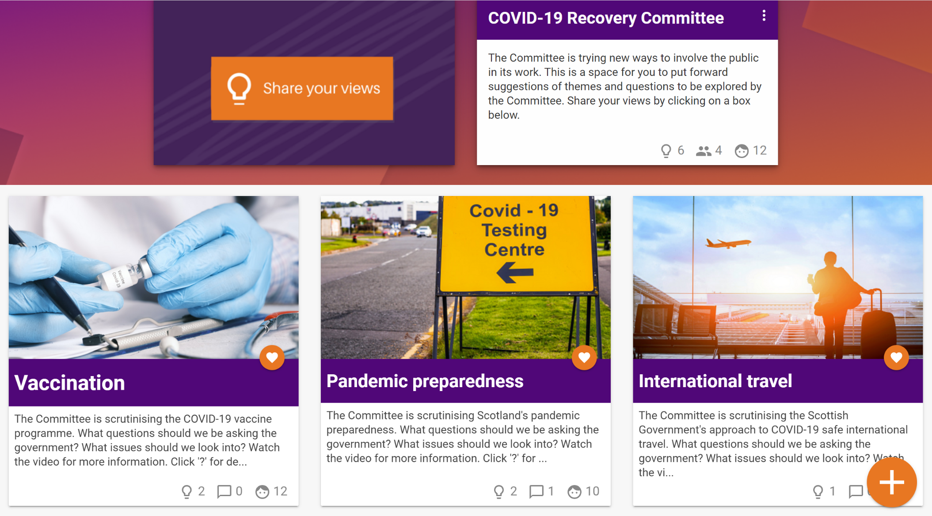
COVID-19 Recovery Committee
What questions would you like answered? Conversation Guide

parliament.scot/covid-questions

October 2021
The Scottish Parliament’s COVID-19 Recovery Committee regularly meets with Ministers from the Scottish Government to examine their work and hold the government to account. We'd like to hear about the questions you have about Covid-19 Recovery in Scotland.

We’ve set up a website where you, and your community, can put forward suggestions for questions and join the discussion to help inform the work of the Committee.

This guide is to help you have conversations in your Community and then upload them to the discussion website, which can be accessed via: parliament.scot/covid-questions

Contents

Add your questions………………………………… page 2
Vaccination…………………………………………………… page 3
International Travel…………………………………………. page 4
Rules for Staying Safe……………………………………... page 5
Discuss other questions………………………….. page 6

How to use this Conversation Guide

This conversation guide has been produced to support you to have your own discussions about issues related to COVID-19 recovery and feed your views into our online discussion space.

If you wish to send in your suggestions manually please print this guide, fill in your suggestions, and return your suggestions for questions to:

PACT, Q1.07, The Scottish Parliament, Edinburgh EH99 1SP
Add your questions

Vaccination

What questions do you have about the vaccination programme?

We would like to know…

Provide some more detail about your question…

Visit: https://engage.parliament.scot/group/10985 to enter questions from your discussion.

International Travel

What questions do you have about COVID-19 and international travel?

We would like to know…

Provide some more detail about your question…

Visit: https://engage.parliament.scot/group/10986 to enter questions from your discussion.

Rules for staying safe

What questions do you have about COVID-19 rules and health protection measures (face masks, social distancing, testing, self-isolation etc.) ?

We want to know…

Provide some more detail about your question…

Visit: https://engage.parliament.scot/group/11051 to enter questions from your discussion.
Discuss other questions

Other people and groups will be taking part in the conversation online. Take a look at the other questions on the website and discuss with your group:

Do you like or dislike any of the suggested questions?

Our thoughts on suggested questions on the site
We like these suggestions for questions… | We dislike these suggestions for questions…

Contact Us

If you want to get in touch, you can contact the Participation and Communities Team.

Address: Q1.07, The Scottish Parliament, Edinburgh, EH99 1SP

Phone: 0131 348 5000 or 0800 092 7500 (freephone)

Email: engage@parliament.scot

Twitter: @Engage_SP

.

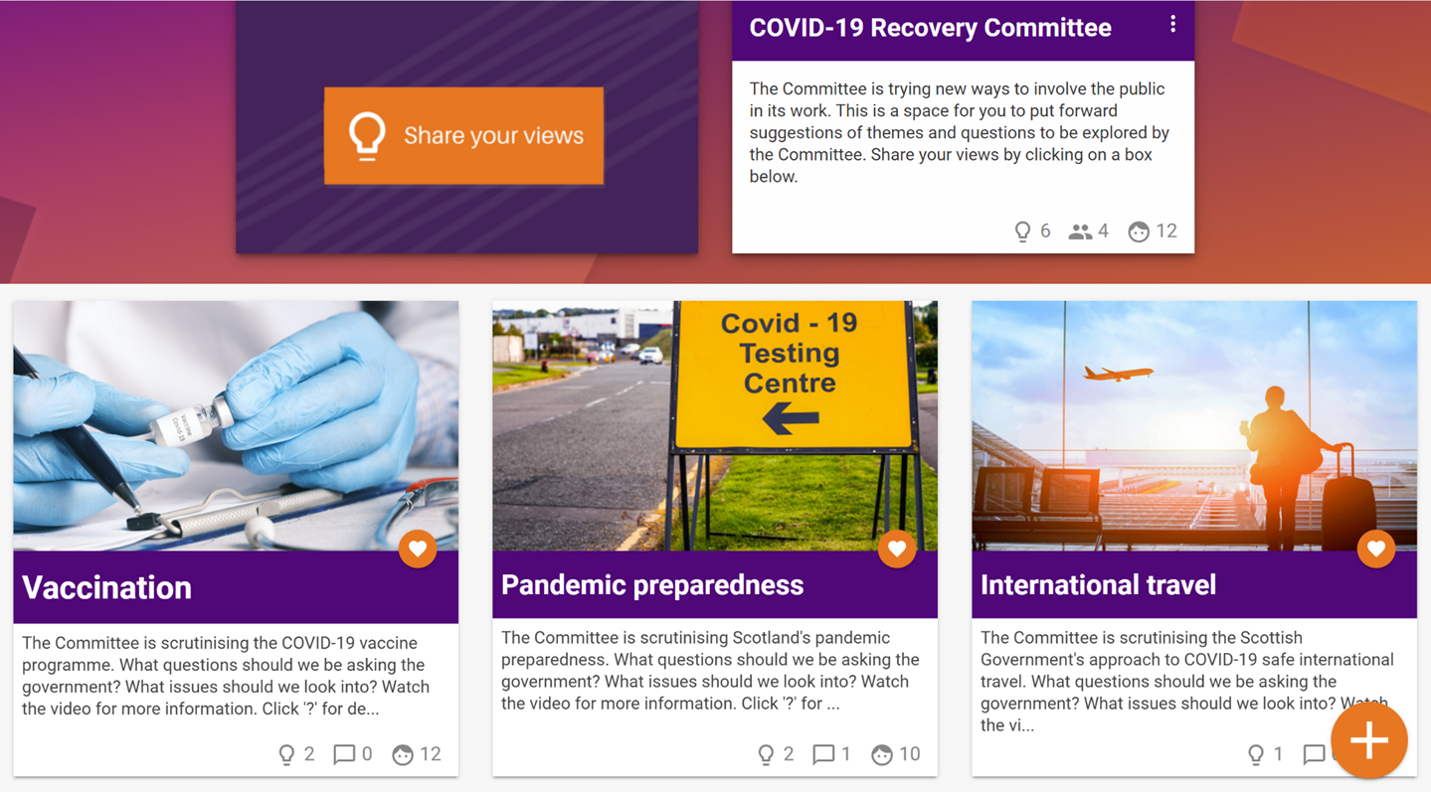
parliament.scot/covid-questions

