Dedridge Regeneration group
Tuesday 18th January 2022
Microsoft TEAMS meeting 6.30pm
Agenda items | Notes | Actions
Presentation – none Jay Haston from Wave to be invited to next meeting. 10 minutes presentation and 10 minutes at start
of meeting for questions and answers Eddie

further suggestions – Kidzeco?

Welcome  Apologies | Karon Langan, Cllr Heggie, Cllr MacAulay, Russell Hastie (LRT, DCC), Eddie Millar, David Liddell(DCC, CMC, WLBL), Lesley Keirnan  Joyce Robertson, Nikki Buckley, Eddie Anderson, Cllr Fitzpatrick, Ross Hutchison, Cllr Shemilt, Ellie Anderson, Mike Duncan, June Hall
- Time and day of future meetings | Discussion on best time and days to have the meetings – pole to go out and ask people best option – survey hero pole to be conducted. Agreed to have next meeting as agreed at 6pm and change thereafter to agreed new day and time when the pole is completed | Lesley/all
- Place based funding | Funding has been awarded for the cycle track and demolition of the barns at the side of Crofthead. WLC undertaking the work. Next stages? What do we need to do to enable us to access the Capital Regeneration Fund? Is there a will? Requiring a Business model in place | Crofthead MC
- Jamboard | Members were asked to contribute to the Jamboard page 17 with achievements over the past year at the meeting and out with before the next meeting to see where we should be focusing this coming year  Link to Jamboard: https://jamboard.google.com/u/0/d/1Hqd_8hpH6hlx4Ba2E0Yl6cMPyyANlEGaturiZCzpXtM/viewer?f=0 | all
- Environ (Litterpicking/flytipping, trollies dog fouling) | Litterpicking Statistics from October to December 2021  66 people have been out litter picking over the period on 4 litter picks collecting a total of A total of 96.5 bags as well as other items such as trollies, bikes, tyres, signage, bed end and pieces of wood etc. this has resulted in a total of 2739 hours dedicated by litter pickers over the period.  The group undertook their first group litter pick of 2022 on Saturday 15th January, which was a great combined effort, with people from West Lothian Litter pickers joining too.  The WLLP have kindly donated an extra-long picker, a grappling hook, a couple of dustpan and brushes sets and some gloves for Karon to share with the group, which she was able to dish out to a few new Dedridge recruits on Saturday.  One new person did raise the question of How do we get the word out about litter-picking to those who are not on Facebook? I would be really interested to hear people’s views on that one.  3 new volunteers
- Environ - community growing/gardening/hedges improvements | Health centre update from Ross Hutchison (resident)– raised bed  Ross has been given authority from the health centre to plant some wild flowers on the area outside the health centre. He has purchased bulbs and seed. He intends this year will be a wild flower area but year on year additions. The plan is to keep it in flowers as long as possible. Look for funding for this? Can we link it with the Crofthead Community Garden?  Crofthead community garden event was well attended with new faces – suggestions to take this forward with a spring event. Thinking caps for next month’s meeting! | all
- Activities for YP and families | Skatepark – next meeting  Young people’s unit un the centre – follow on to next meeting | Next meeting
- Safety | Update from Karon (resident) Hand rail – Karon remotely undertook a deputation at the last Livingston South Local Area Committee. Funding awarded from the COVID-19 recovery fund to support the project. Cllr Shemilt is liaising with Roads over the cost and design. It will go to the LAC for approval of side or central rail.  Update from Eddie (resident) – Street Lighting  Eddie has completed the street lighting audit. As this was undertaken last year he is going to check over the few bulbs and report any through the appropriates channel  Map of current lighting: https://maps.westlothian.gov.uk/wml/Map.aspx?MapName=StreetLighting form WLC  Reporting a broken street light  https://www.westlothian.gov.uk/article/43051/Report-a-Broken-Street-Light | Eddie
- Update on Milestones project | Update from Ross Wylie (resident) - Milestone project, Town Centre Fund )  The "Dedridge milestone" has now been re-sett with an accompanying interpretation board alongside of it. By somewhat of a coincidence on the adjacent Newyearfield Farm Footpath the streetlight that stands directly in front, shines on and illuminates this milestone focal point like a spotlight excellently at night and definitely adds to its presence. This feature has had many passing admirers already, with some asking "how long has the milestone been there?"!  The "Kirkton milestone" previously seen lying at an extreme angle within the Klondyke Garden Centre car park, has now been re-sited back to its original location as noted on historic maps, (and now sits at the road junction to Hunter Rd, approximately 120m away). Again, already several admirers have been seen viewing the feature and obviously impressed when reading the interpretation board showing the historic details of the milestone.  I've attached some before and after photographs of the above two milestones etc for all to see.  Although there has been some "errors made " with the siting of interpretation noticeboards etc alongside the Howden milestone and Howden Toll cottage, these I am assured are in the process of being resolved.  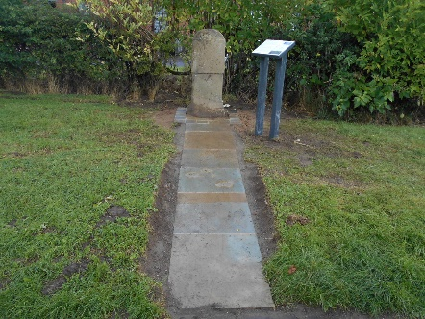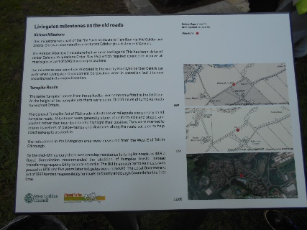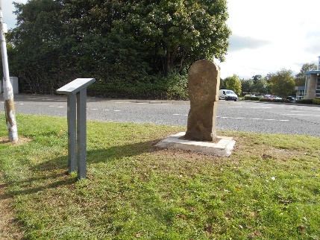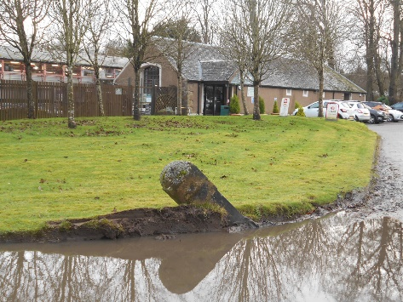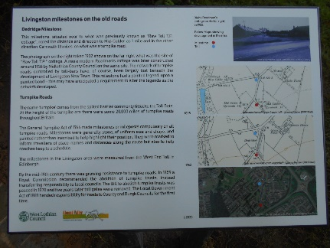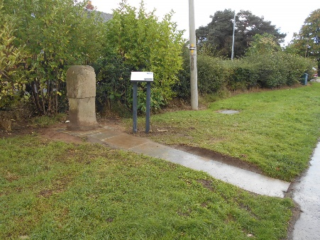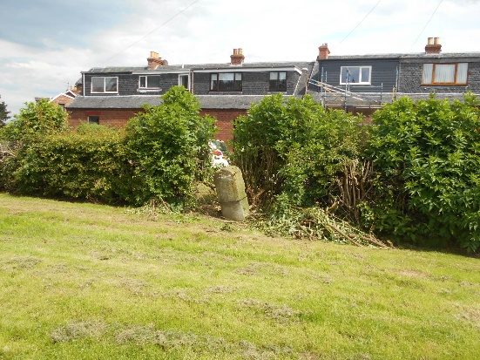 | To be noted
- Services and organisations update | Almond Housing Community Soup funding – email circulated this morning. Contact Barbara if thinking of applying at Barbara.Boertien@ALMONDHA.ORG.UK  Libraries are now nearly back to normal with no appointment required and Bookbug session and book groups all back meeting …see website for further information  Lanthorn Library @ Torridon house is also now running a Lego club ……….again information on the website but would be good to promote….  We are always looking for ways to promote the library or activities that we can offer in the Library ….so please feedback any suggestions.  We are planning on holding an open day ……..when regulations allow to encourage customers to use the services….but remember to also promote the online services that are free and also available…..i.e. free magazines we have over 3000 to choose from for adults and children also, free audio books and eBooks.  If you’re not a member then advise on how to join is available on line.  Customer Information Services are open for all enquires but are operating an appointment service these can be booked by calling 01506 850750 lines are operated Monday to Thursday 9-16:30 and Friday 9-15:30  free travel for under 22 years of age……..the application process opened on Monday 10th with free travel across Scotland being available to everyone under the age of 22….however due to the current situation only people that require to be travelling have been asked to apply ie people traveling for education or work and requiring public transport all other applications have been asked to delay their application …there is a potential 480000 applications in West Lothian Council that have been identified so a busy time………….  Most groups have returned at Community Centres and risk assessments completed …obviously this changes on a day to day basis to follow the changes to regulations relating to COVID.  Crofthead Community Garden – Green Gym is back in 1 day per week.  An agreement with a local tree surgeon has resulted in an abundance of mulch being brought to the garden  Livingston Round table - funding and support is available for communities through groups and organisations - continue through Jamboard and next meeting
- Poverty | Household bills, food poverty. Discussion around what those most disadvantaged are facing these days. Families are struggling. Think about how we can support working collaboratively with the community food outlets, anti-poverty services and as community together. Food parcels, cooked meals – some suggestions. For next meeting | all
- Health & well Being | Discussion on LRT, Andy’s Man club and WAVE club 70/30 campaign. LRT hope to visit an Andy’s man club group to inform them about LRT and the work they do in the first instance. | To be noted
Date and time of next meeting | Tuesday 15th February 2022  6pm  Microsoft TEAMS

