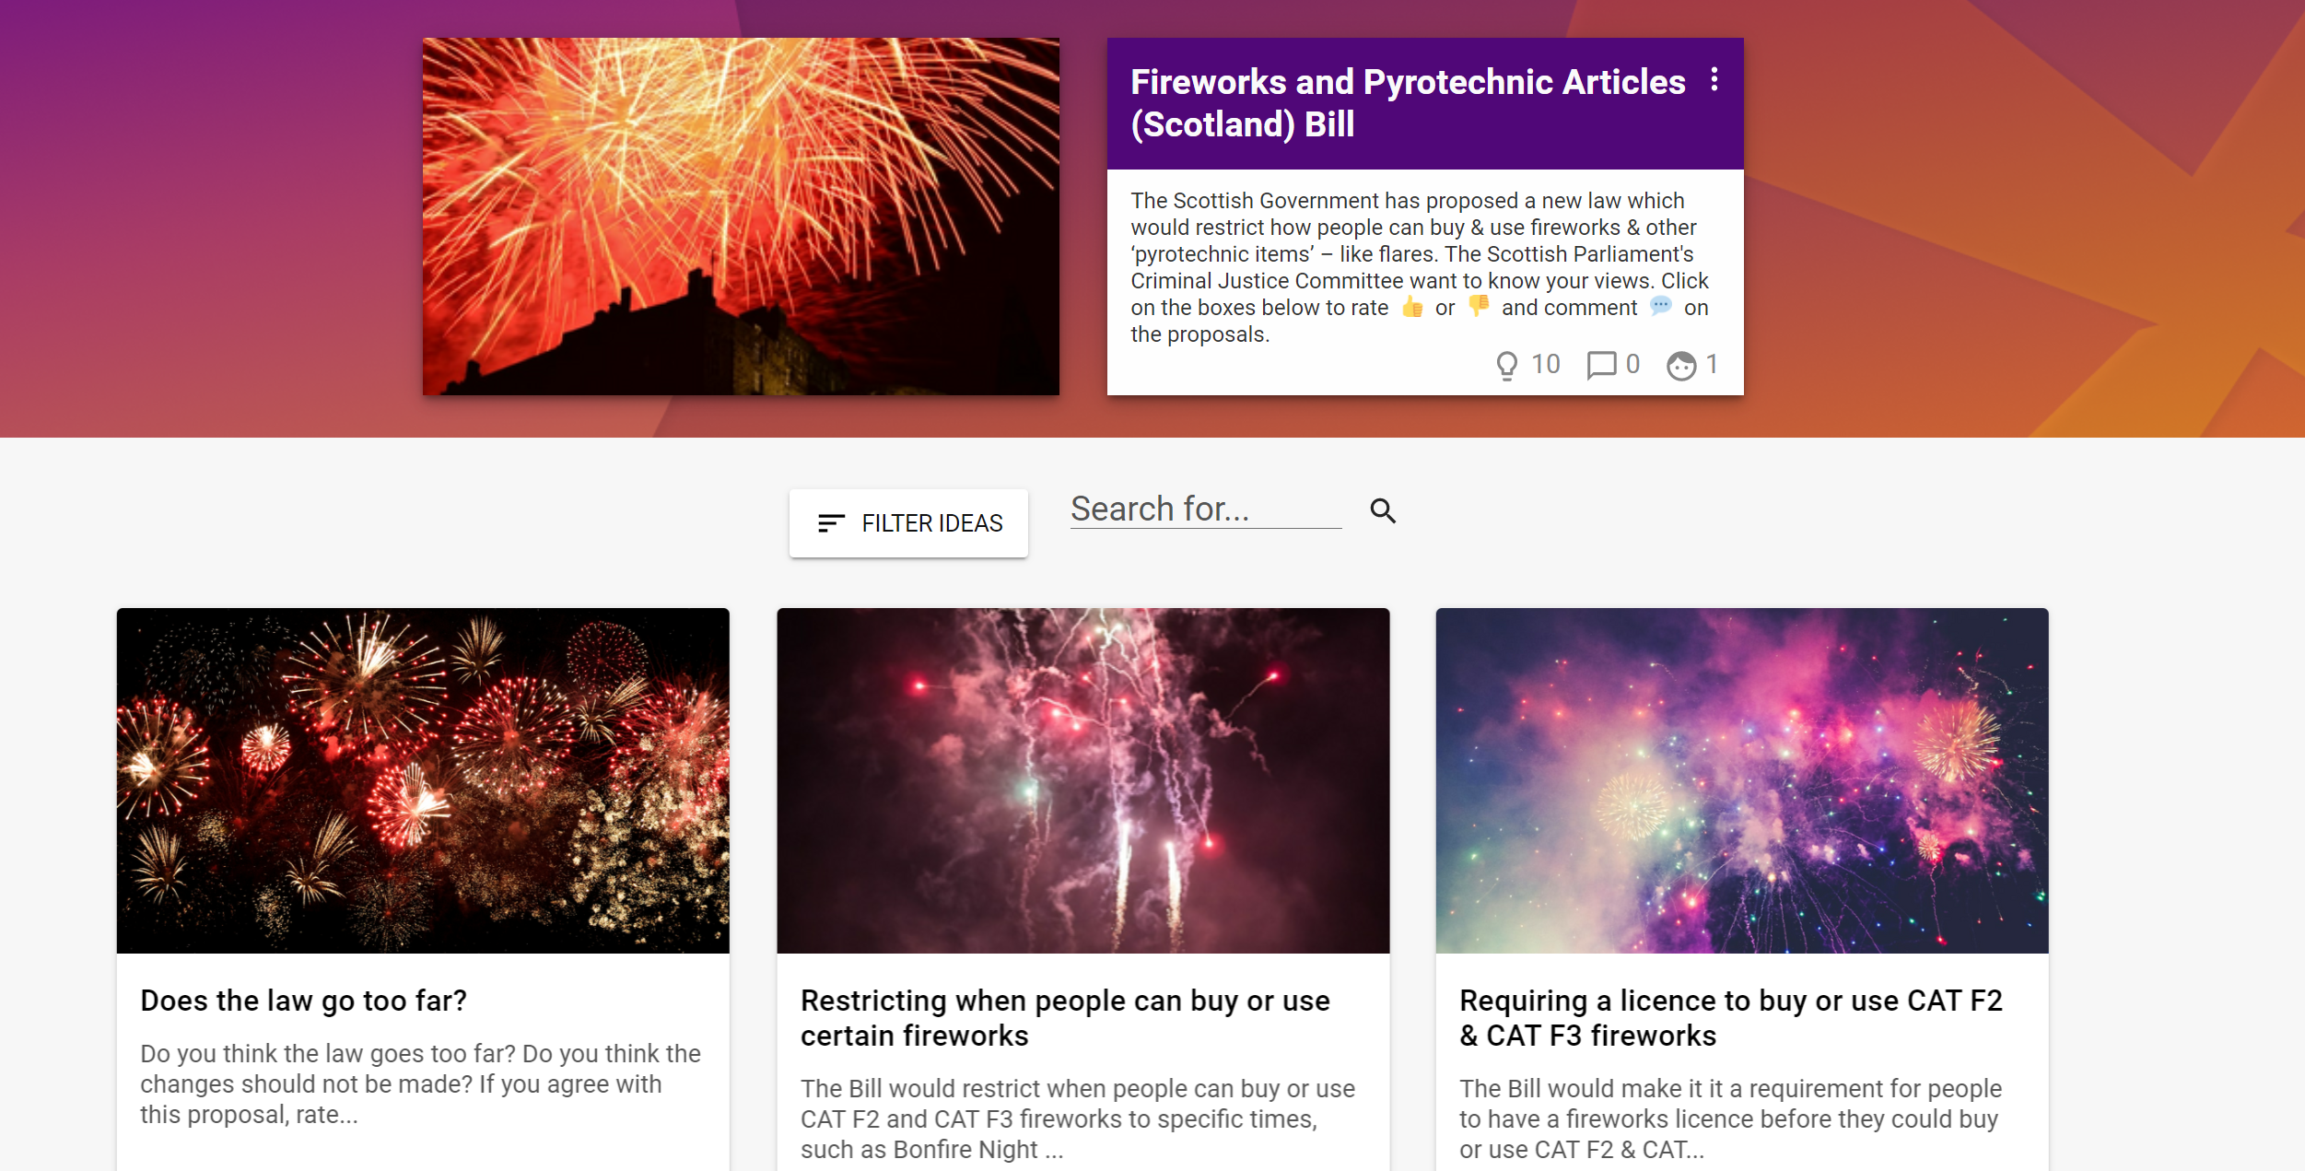
Fireworks and Pyrotechnic Articles (Scotland) Bill

Criminal Justice Committee

Conversation Toolkit

February 2022
Contents

How to use this Conversation Toolkit………………………………………………………….. PAGE 3
About the Criminal Justice Committee…………………………………………………………. PAGE 4
Share your views: Fireworks in Scotland…………………………………………….………... PAGE 6
What fireworks are impacted by the Bill?....... …………………………………………..... PAGE 7
Restricting when people can buy or use certain fireworks………………………….... PAGE 8
Requiring a licence to buy or use CAT F2 & CAT F3 fireworks………………………… PAGE 9
Paying £30-50 for a licence to buy or use certain fireworks…………………..……… PAGE 10
Taking an online course before getting a fireworks license………………..………... PAGE 11
Local councils creating 'firework control zones.'…………..….……….…………………. PAGE 12
Give police powers to stop, search & seize certain fireworks………..……………… PAGE 13
Making it illegal to give certain fireworks to under 18s………………………………… PAGE 14
Restrict the use of fireworks & pyrotechnics at events…………………..……………. PAGE 15
Does the new law go too far?......................................................................... PAGE 16
Should the new law go further?..................................................................... PAGE 17
Contact Us……………………………………………………………………………….………………….. PAGE 17

The Scottish Government has proposed a new law which would restrict how people can buy and use fireworks and other ‘pyrotechnic items’ – such as flares.

MSPs on the Scottish Parliament’s Criminal Justice Committee are looking at the details of the proposals, and want to know what people think about them.

Knowing your views will help them think about ways that could improve the proposed law, and whether the draft Bill should be passed into law by the whole Parliament.

How to use this Conversation Toolkit

We’ve set up a website where you, and any groups you work with, can let the Committee know what you think. The contributions made on the website will be shared with the Committee to help them with their ongoing work in this area.

This toolkit is designed to help you have conversations with groups of children and young people you work with and then add them to the discussion website, which can be accessed via: https://engage.parliament.scot/group/12657

You can add comments in writing or by uploading an image or a video.

Throughout the toolkit we have highlighted the main parts of the Bill. You can then use the outcomes of your discussions to contribute to the discussion website.

You do not have to look at every part of the Bill – you might only want to discuss one or two areas that are most important to you and the people you work with.

We have also included some information about the Committee which might be helpful to explain to young people who the Committee is and what it does.

If you wish to send in your suggestions manually please print the relevant pages from this toolkit, fill in your suggestions, and return them to:

PACT, Q1.07, The Scottish Parliament, Edinburgh EH99 1SP
About the Criminal Justice Committee

Introduction to the Committee

The Committee considers key issues within the Criminal Justice system in Scotland. These can include
- Police Scotland and the Scottish Fire and Rescue Service
- Courts, including the Scottish Courts and Tribunals Service
- Prosecution and the work of the Crown Office and Procurator Fiscal Service
- The Scottish Prison Service and community sentencing

The Committee is made up of ten Members of the Scottish Parliament (MSPs) from across the political parties represented in Parliament. More information about the Committee and its members can be found on the Committee page on the Scottish Parliament website.

More information about Committees in the Scottish Parliament can be found in this short video. A short video on how laws are made in the Scottish Parliament can be viewed here.

How the Committee works

Committee members work together to look at new laws by hearing from experts, organisations, and members of the public about what the bill would do. It then writes a report about what it has heard and makes a recommendation to the rest of the Parliament. The committee recommend the Parliament either agree or disagree with the purpose of the bill (the "general principles"). The whole Parliament then debates and votes on the bill.

Members of the Committee

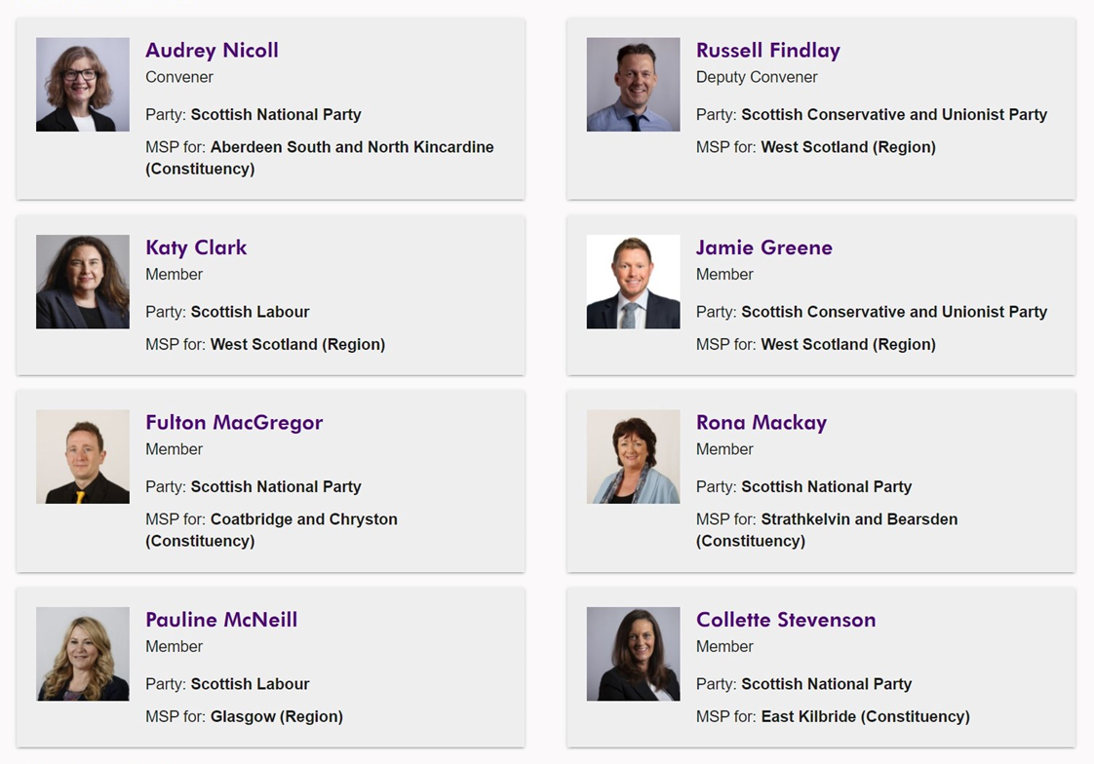

Share your views: Fireworks in Scotland

The main parts in the Bill are:
- Restricting when people can buy or use certain fireworks
- Requiring a licence to buy or use CAT F2 & CAT F3 fireworks
- Paying £30-50 for a licence to buy or use certain fireworks
- Taking an online course before getting a fireworks license
- Local councils creating 'firework control zones.'
- Give police powers to stop, search & seize certain fireworks
- Making it illegal to give certain fireworks to under 18s.
- Restrict the use of fireworks & pyrotechnics at events

There is also an option to discuss the following questions:
- Does the new law go too far?
- Should the new law go further?

What fireworks are impacted by the Bill?

Fireworks are categorised by how powerful they are. They go from CAT F1 (the least powerful) to CAT F4 (the most powerful).

CAT F4 already cannot be sold to the general public, and are intended for public firework displays only. CAT F1, which includes items such as sparklers, are also not included in the proposals.

These proposals affect CAT F2 and CAT F3 fireworks.
CAT F2 fireworks should only be used with spectators 8m away (2 cars length) while CAT F3 should only be used with spectators 25m away (a normal swimming pool size).

In the next section we have provided more details about each of these conclusions. There is space to write down reasons your groups agree or disagree with them. There is also a web link to add your views online.

Restricting when people can buy or use certain fireworks
The Bill would restrict when people can buy or use CAT F2 and CAT F3 fireworks to specific times, such as Bonfire Night and New Year’s Eve.
The Bill would allow fireworks to be supplied at the following times:
(a) 7 April to 14 April,
(b) 27 October to 10 November,
(c) 26 December to 31 December,
(d) the first day of Chinese New Year and the 3 days immediately preceding it,
(e) the first day of Diwali and the 3 days immediately preceding it.
If you agree with this proposal rate it up (), if you disagree, rate it down ().
Please tell us why you agree or disagree using the comment boxes below..

We agree because… | We disagree because…

Visit: https://engage.parliament.scot/post/63840 to enter views from your discussion.

Requiring a licence to buy or use CAT F2 & CAT F3 fireworks
The Bill would make it a requirement for people to have a fireworks licence before they could buy or use CAT F2 & CAT F3 fireworks.
CAT F2 fireworks should only be used with spectators 8m away (2 cars length) while CAT F3 should only be used with spectators 25m away (a normal swimming pool size).
When applying for a fireworks license people would need to:
disclose any relevant criminal convictions they may have;
disclose any details of any previous fireworks licenses that were revoked or cancelled;
and prove they had completed a fireworks training course.
If you agree with this proposal, rate it up (), if you disagree, rate it down ().
Please tell us why you agree or disagree using the comment boxes below.
We agree because… | We disagree because…

Visit: https://engage.parliament.scot/post/63842 to enter views from your discussion.
Paying £30-50 for a licence to buy or use certain fireworks
The Bill enables the Scottish Government to charge people when they apply for a licence to buy or use CAT F2 and CAT F3 fireworks.
If this is law is introduced, there could be a licence fee of between £30 and £50. Is this cost range too high, too low, or about right?
If you agree with this proposal, rate it up (), if you disagree, rate it down ().
Please tell us what you think of the cost range using the comment boxes below. Is £30-£50 too high, too low, or about right?
We agree because… | We disagree because…

Visit: https://engage.parliament.scot/post/63843 to enter views from your discussion.
Taking an online course before getting a fireworks license
The Bill would require people to take a basic online course before they can get a licence to buy and use CAT F2 and F3 fireworks.

If you agree with this proposal, rate it up (), if you disagree, rate it down ().
Please tell us why you agree or disagree using the comment boxes below.

We agree because… | We disagree because…

Visit: https://engage.parliament.scot/post/63844 to enter views from your discussion.
Local councils creating 'firework control zones.'
The Bill would give local councils powers to create zones where fireworks can’t be used: "firework control zones:
Before making a place as firework control zone (or amending or revoking a zone)
a local council would need to publish a proposal about the zone, including the reasons for the zone and its boundaries. The council would also need to consult the local community.

If you agree with this proposal, rate it up (), if you disagree, rate it down ().
Please tell us why you agree or disagree using the comment boxes below.

We agree because… | We disagree because…

Visit: https://engage.parliament.scot/post/63845 to enter views from your discussion.
Give police powers to stop, search & seize certain fireworks
The Bill would give police more powers to stop and search people and seize CAT F2 and F3 fireworks.
If a police constable had reasonable grounds for suspecting that a person has committed or is
committing an offence, the constable may—
(a) search that person without warrant, and detain the person for such time as is
reasonably required to permit the search to be carried out,
(b) stop and search a vehicle (and anything on or in it) without warrant,
(c) seize and retain any item found in the course of a search which may be relevant
to the suspected offence.

If you agree with this proposal, rate it up (), if you disagree, rate it down ().
Please tell us why you agree or disagree using the comment boxes below.

We agree because… | We disagree because…

Visit: https://engage.parliament.scot/post/63846 to enter views from your discussion.
Making it illegal to give certain fireworks to under 18s.
While a person must be aged 18 years or over to buy CAT F2 and CAT F3 fireworks, at the moment an adult can give CAT F2 and CAT F3 fireworks to someone under the age of 18 years.
The Bill would make it a criminal offence for someone aged 18 years or over to give CAT F2 or CAT F3 fireworks to someone under 18 years.

If you agree with this proposal, rate it up (), if you disagree, rate it down ().
Please tell us why you agree or disagree using the comment boxes below.

We agree because… | We disagree because…

Visit: https://engage.parliament.scot/post/63847 to enter views from your discussion.
Restrict the use of fireworks & pyrotechnics at events
The Bill will give the Scottish Government new powers to make regulations to control the possession or use of any fireworks or distress and signal flares at certain locations (such as sports grounds) or at certain events (such as public music festivals, or public marches/processions).

If you agree with this proposal, rate it up (), if you disagree, rate it down ().
Please tell us why you agree or disagree using the comment boxes below.

We agree because… | We disagree because…

Visit: https://engage.parliament.scot/post/63850 to enter views from your discussion.

Does the new law go too far?

Do you think the law goes too far?

Do you think the changes should not be made?

If you agree with this proposal, rate it up (), if you disagree, rate it down ().
Please tell us why you agree or disagree using the comment boxes below.

We agree because… | We disagree because…

Visit: https://engage.parliament.scot/post/63849 to enter views from your discussion.

Should the new law go further?

Do you think the law should go further?

For example, banning the general public from buying or using all CAT F2 and CAT F3 fireworks?

If you agree with this proposal, rate it up (), if you disagree, rate it down ().
Please tell us why you agree or disagree using the comment boxes below.

We agree because… | We disagree because…

Visit: https://engage.parliament.scot/post/63848 to enter views from your discussion.

Contact Us

If you want to get in touch, you can contact the Participation and Communities Team.

Address: Q1.07, The Scottish Parliament, Edinburgh, EH99 1SP

Phone: 0131 348 5000 or 0800 092 7500 (freephone)

Email: engage@parliament.scot
Twitter: @Engage_SP

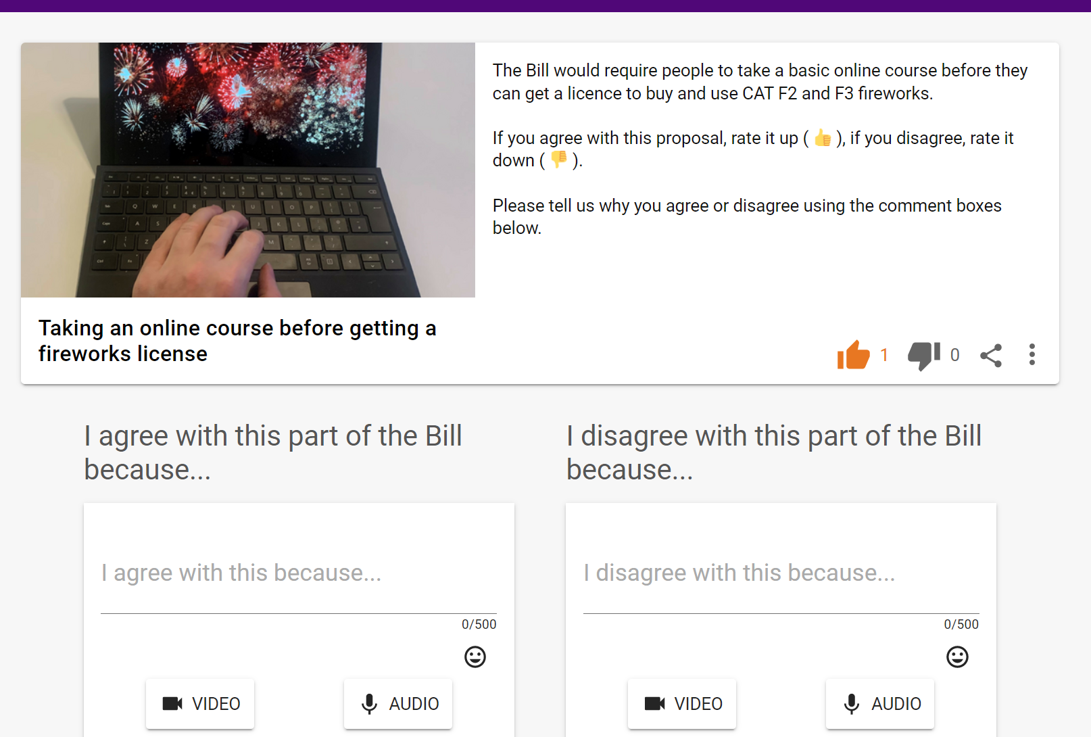
© Parliamentary copyright. Scottish Parliamentary Corporate Body 2022

