NHS Lothian: Community Benefit Gateway Brief Guide

What is the Community Benefits Gateway?
Scotland spends approximately £2.5 billion on NHS goods and services each year, working with thousands of NHS Scotland suppliers. The Community Benefit Gateway allows us to further develop our services and use the power of procurement to deliver a wide range of added value to hospitals, patients and communities.
The Community Benefits Gateway is a platform to help match the array of skills and offers of NHS Scotland’s ‘can do’ suppliers, with the real community needs – in doing so, enabling procurement spend to go even further in improving lives, and creating healthier, and safer communities across Scotland.

How does it work?
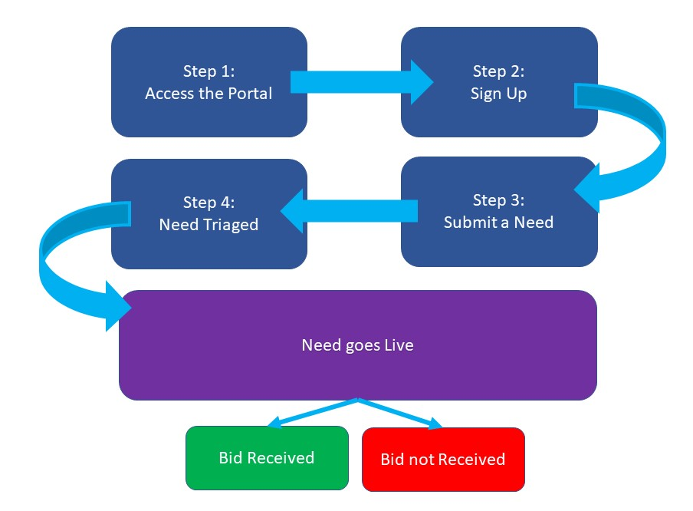

Step 1: Accessing the portal
The portal can be accessed via this link
https://nhsnss.service-now.com/community_benefit

There are helpful information documents on this page which can be downloaded and also a video to watch for further guidance
https://www.nss.nhs.scot/procurement-and-logistics/sustainability/access-our-community-benefit-gateway/

Step 2: Signing Up
Sign up using your organisation’s email address and fill out all the details. This is a FREE service which is available to third sector and community groups.

Step 3: Submit a Need
Once registered, look for the red bar to “submit a need”. You’ll then be asked to fill in an application form. Here is the information you’ll require:
Field | Description
Name | *auto filled with registration information
Organisation | *auto filled with registration information
Organisation details | Please provide a brief description of your organisation's profile (i.e. activities, mission, goals).
Location | Please select NHS Lothian
Project Name / Title | Please provide the name of your project/community need.
Project Aim(s) / Specifics of support needed | Please enter a summary of the aim of your project and what your ‘need’ is. Be clear about what it is you are looking for, is it equipment, time, training, etc? E.g. don’t just say you need a room painted. Specify if you need materials and/or, someone to carry out the task, and/or training and support to teach your users to do the task etc.
Beneficiaries | Specific groups whom you believe will directly benefit from your project
Support Category | How the community will benefit from your project
What evidence is there to support the need for your project? | Summary of your knowledge of available evidence
What impact will your project have? | Summary of overarching impact
How will you measure the success of your project? | Can you identify any measures i.e. number of people supported?
Project Target Start Date | Select date when you would like project to start
Project Target Delivery | When do you hope to complete
Project Delivery Deadline Date (if applicable) | Is there an absolute end date when the project must be completed
Project Location (Postcode) | Delivery location for reporting purposes mandatory field.

What is a need?
A community initiative (or ‘need’) is something which improves the economic, social and environmental wellbeing of a local area. So a third sector organisation might ask for support with volunteering, work placement opportunities, the provision of professional advice, assistance with building community facilities, resources and much more.

Although the word ‘need’ is frequently used here, we would prefer you to think about it as more of a ‘wish’. If you really need something the Gateway is not likely to be the best place to look as your request may take some time to be picked up by a supplier, or may not be picked up at all.

Step 4: Submitting Your Need
A panel of NHS Population Health representatives, supported by Third sector Interface and Procurement colleagues will endeavour to assess your submission to the Gateway within 7 days. This is to ensure the need is relevant and provides a benefit to the local community. If your application has been successful, you will receive a confirmation email and the need will go live on the portal. If your need is rejected by the panel, an email will be sent to you with an explanation of why this has been rejected. From this point, if applicable, you can amend your application and resubmitted with these changes for further review by the panel. Some applications may require further information; you may be emailed directly by a member of the panel.
Your need is live! Once your need is live, NHS suppliers are able to see your need and place a bid if they are able to/want to fulfil this.

Bid not received: if a bid is not received within 1 year of the need going live on the portal, it will automatically be declined and if needed, you can apply again.
Bid received: Congratulations a supplier has placed a bid and would like to fulfil your community need. You’ll receive an email with clear instructions on your next steps:
- Contact the supplier to find out exactly what their bid entails (you may receive more than one bid so it’s important to see what’s on offer)
- Depending on your decision you should follow the link on the email to either accept or reject the bid.
- If you accept the bid – you should facilitate this directly through the supplier and they have 6 months to fulfil this.
- If you reject the bid – your need will still be live for future bids

It is important that you initiate the contact with the supplier in order to negotiate the terms of the bid (e.g., discuss the offer from supplier, dates, milestones…etc.). If you experience issues in getting back to the supplier, please click the “Need Assistance?” button at the top of the Gateway page and a member of the CB Gateway National Team will be back in touch with you.

As noted above there is a ‘Need Assistance’ button on the Gateway portal to submit questions or get support. If you are not yet registered for the Gateway you can contact your local NHS or Third Sector Interface representative at the email addressed below:

Edinburgh

Ian Brooke at EVOC: ian.brooke@evoc.org.uk
John Brennan at NHS Lothian: john.brennan@nhslothian.scot.nhs.uk

West Lothian

Stuart Barrie at Voluntary Sector Gateway West Lothian: stuart.barrie@vsgwl.org
Laura Dougall at NHS Lothian: laura.dougall@nhslothian.scot.nhs.uk

Midlothian

Natalie Thompson at Midlothian Voluntary Action: natalie.thomson@mvacvs.org.uk

Jillian Adie at NHS Lothian: jillian.adie@nhslothian.scot.nhs.uk

East Lothian

Tracey Redpath at Volunteer Centre East Lothian: tracey@volunteereastlothian.org.uk

Lorna Bellany at NHS Lothian: lorna.bellany@nhslothian.scot.nhs.uk

