1. **Background & Aims**
   1. **West Lothian Local Outcomes Improvement Plan**

The West Lothian Local Outcomes Improvement Plan outlines a vision that ‘West Lothian is a place where everyone has the opportunity to enhance their mental and physical health and wellbeing’. A key priority has been identified as *Developing a preventative approach to population level wellbeing*.

A partnership working group[1] has been established to progress developing a preventative approach and one of the groups actions is to develop and raise awareness of a West Lothian specific ‘6 Ways to Wellbeing’ model, with both the public and workforce.

There is a well-recognised and evidenced based ‘[5 Ways to Wellbeing](http://samh.org.uk/about-mental-health/self-help-and-wellbeing/five-ways-to-better-mental-health)’ model, to which the group have added a sixth ‘way’ – financial wellbeing – to recognise the huge impact of financial security and cost of living on wellbeing. The group recognise the need for people to have support to achieve Ways to Wellbeing and the importance of not putting all the responsibility onto individuals. Therefore, it is crucial for there to be a good understanding of this model by those working on the frontline in West Lothian so they can offer support and work with people to improve their wellbeing.

* 1. **Wider Wellbeing Workforce Survey**

The group undertook the wider wellbeing workforce survey to understand current awareness around mental health and wellbeing in West Lothian, the Ways to Wellbeing model and what additional information and resources would be useful to support people in their roles. The survey had the following aims:

* To provide a baseline of information about awareness and confidence of the wider workforce in mental health and wellbeing (including the Ways to Wellbeing model).
* To inform the development of a section to support the wider wellbeing workforce on West Space (referred to as a practitioner’s area in the survey).

The target audience was anyone working/volunteering in West Lothian who interacts with the general public regularly in their role i.e. the wider wellbeing workforce[2].

1. **Survey Delivery**
   1. **Survey Methodology**

An online secure survey ran from 31st August to 22nd of September 2023 and all responses were anonymous. It was shared widely across NHS Lothian, West Lothian Council, Education, the Third Sector, Community Sport/Leisure, Police and other relevant sectors. 551 responses were received in total.

* 1. **Survey Limitations**

There is acknowledgement of the limitations of the survey. The target audience was very large and cannot be completely defined or captured in terms of size. Therefore, it is not clear what proportion of the potential audience responded. It is likely that respondents with more experience of mental health and wellbeing issues within their role, or personally, may have been more likely to complete the survey and therefore this would have resulted in a bias of results.

Therefore, this survey provides a snapshot to inform actions and plans but cannot be taken as completely representative of the West Lothian population.

* 1. **Sector Differences**

Throughout this report responses have been reviewed across sectors to determine if there were many differences depending on where people worked/volunteered. In the main, the summary responses were broadly representative of each sector. Where there were more noticeable differences, these have been highlighted.

1. **Survey Respondents**
   1. **Respondents place of work**

Participants were asked to detail where they worked to build up a picture of who completed the survey.

Chart 1: Where do you work/volunteer?

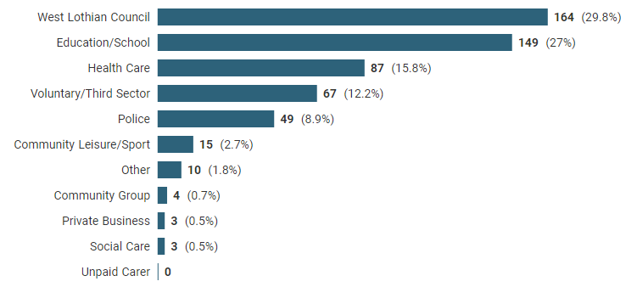

West Lothian Council, Education/School, Health Care and the Third Sector made up over 80% of responses. Unfortunately, there were low responses from Private Business, Social Care and Unpaid Carers despite the survey being shared with contacts in all of these sectors. The low response for Community Groups is likely attributed to most respondents viewing themselves as part of the Third Sector and a lack of clear definitions provided for each sector category.

The results showed around 30% of respondents work/volunteer with all ages and life stages.

Of the remaining 70%, approximately 40% of people work with children and young people and

60% work with adults aged 18+ at a range of stages. Therefore, there was good representation from people working across the life stages.

* 1. **Respondent’s roles**

In terms of roles, respondents were asked which category best described their role, with the following results.

Table 1: Which category best describes your role?

|  |  |
| --- | --- |
| Mental health and wellbeing is a primary part of my role | 15% |
| Mental health and wellbeing is a secondary part of my role | 27% |
| Mental health and wellbeing is not part of my role but I DO come into contact with people struggling with their mental health and wellbeing | 52% |
| Mental health and wellbeing is not part of my role and I DO NOT come into contact with people struggling with their mental health and wellbeing | 4% |
| Unsure if mental health and wellbeing is part of my role | 2% |

The results show that a large majority of respondents (94%) support people as a primary/secondary part of their role or come into contact with people struggling with their mental health and wellbeing. Only 6% of respondents did not class mental health and wellbeing as part of their role or do not come into contact with people who are struggling.

Despite mental health not being part of their role, just over half of respondents reported that they still come into contact with people who are struggling with their wellbeing. This highlights the nature of the wider wellbeing workforce and the importance of ensuring these people feel confident in their knowledge about mental health and wellbeing and where to signpost for more support.

* 1. **Respondent’s frequency of contact**

The next question for respondents related to frequency of contact with people.

Chart 2: In your role, how often do you come into contact with people who are struggling with their mental health and wellbeing?

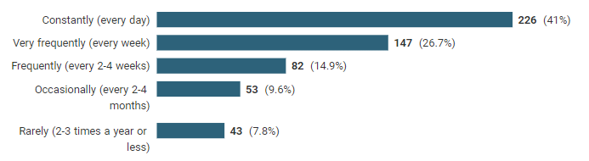

Just over 40% of respondents reported that they come into contact with people who are struggling with their mental health and wellbeing every day. This rises to two thirds of respondents reporting they come into contact with people who are struggling with their mental health and wellbeing every week. Over 80% of respondents had frequent contact with people who are struggling which again highlights the importance of this workforce and the need for them to have access to appropriate information and awareness of where to signpost.

In relation to sectors, the most common response from respondents in West Lothian Council, Education/School, Health Care, Voluntary/Third Sector and the Police was ‘constantly’ highlighting this is affecting people working across a range of sectors.

* 1. **Respondent’s workplace wellbeing support**

Respondents were also asked how supported they felt by their organisation with their own mental health and wellbeing. The results are showed in table 2.

Table 2: In your role, how supported do you feel by your organisation with your own mental health and wellbeing?

|  |  |
| --- | --- |
| Well supported | 22.1% |
| Adequately supported | 40.3% |
| Not supported | 23.4% |
| Unsure | 12.2% |
| Not applicable | 2% |

There is scope for improvement in organisational wellbeing support with only 22% of respondents reporting they felt well supported by their organisation with their own mental health and wellbeing. Given that 80% of respondents are from the public/third sector this presents an opportunity to have an increased focus on more support for people’s health and wellbeing within an organisational setting.

Respondents from the Third Sector felt most supported, with 60% reporting they were ‘well supported’. Responses from Health Care, West Lothian Council and Community Leisure/Sport were broadly in line with the average. However, respondents from Education/School and Police showed low numbers feeling ‘well supported’ and had the highest proportion of respondents feeling ‘not supported’.

* 1. **Respondent’s organisation contributions and opportunities for improvements**

Respondents were asked to explain how the work of their organisation/group promotes positive mental health and wellbeing in West Lothian and in what way this could be improved. Around 40% of people completed this free text question.

In terms of promotion of positive mental health, responses covered the following:

* Organisational wellbeing initiatives
* Team meetings/supervision
* Flexible/supportive working environments
* Information and signposting
* Local services that support wellbeing
* Health and wellbeing in the school curriculum

Opportunities for improvements could be themed into the following categories:

* Better partnership working across agencies and taking a whole system approach
* More support for staff – stress at work/reduced staff/high workload/non-supportive culture/aggressive behaviour
* More training opportunities and awareness of support
* Addressing root causes of poor wellbeing (e.g. stress at work, cost of living)
* Need for senior buy-in and positive culture
* The importance of physical activity and being outdoors

A selection of responses is provided below to give an insight into various views. These have been selected with a focus on the challenges/issues and opportunities for improvement, as opposed to highlighting the positive work already underway. Additional quotes are contained in Appendix 1.

**West Lothian Council**

|  |
| --- |
| *“In my opinion it needs to be acknowledged that certain roles within the council such as social care roles have a higher risk of staff developing stress and mental health issues and there should be specific strategies for each workplace. Signposting to other services does not prevent the staff member being exposed to considerable stress in their workplace.”* |

**Education**

|  |
| --- |
| *“It is promoted but the reality is that schools are underfunded, understaffed and under resourced. Looking after your H&WB is encouraged but the truth is that the state of the job right now makes it likely for stress and stress-related illnesses and burn out occur frequently, even knowing that one must look after themselves.”* |

**Health Care**

|  |
| --- |
| *“Frequently we encounter patients with mental health issues and we try our best to support them and refer on to specialist services, it can impact their rehabilitation and mean it is difficult to progress rehab/discharge patients and affect waiting list for others awaiting physical rehab. Staff report feeling unskilled in supporting mental health.”* |

**Voluntary Sector**

|  |
| --- |
| *“Mental health is given as a reason for my clients position in nearly every conversation. I really have no idea how this could be improved, it is almost like a pandemic right now.”* |

**Police**

|  |
| --- |
| *“We are regularly and consistently facilitating mental health assessments for those that contact us directly or are referred to us by Scottish Ambulance Service. Mental Health and wellbeing could be improved by having a mental health response team that travel to reports of those in crisis, freeing up police and ambulance time.”* |

1. **Opportunities to Support Wellbeing**
   1. **What is beneficial for people’s wellbeing**

In this section, respondents were asked about what they thought was beneficial for people’s wellbeing, with the possible responses listed as the Six Ways to Wellbeing (although not referred to as such) as illustrated below.

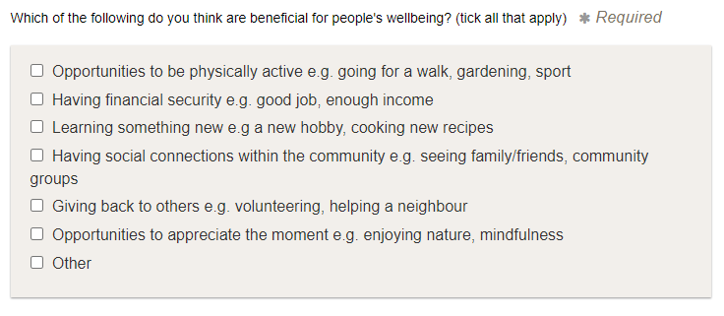

The results showed good general awareness across the board of what is beneficial for people’s wellbeing. The highest responses were for being physically active, having social connections and financial security, with all of these having over 90% of respondents thinking they are beneficial for wellbeing. This was followed by opportunities to appreciate the moment (83%), learning something new (75%) and lastly giving back (72%). Responses across the sectors were in line with the average findings. This was a positive finding, showing good understanding of what is beneficial for people’s wellbeing.

* 1. **Confidence in signposting to ways to wellbeing**

In terms of the confidence in signposting to these opportunities, there was more of a range across responses and a big opportunity to improve and support confidence. Signposting to physical activity/sport, appreciating the moment and giving back to others showed the highest confidence levels. However, even in these categories 35-40% of people were not confident at all or only slightly confident in signposting.

Confidence was more mixed for learning something new, social connections within the community and local mental wellbeing organisations, but again 40-45% of people were not confident at all or only slightly confident in signposting.

Financial security and support for people going through the menopause[3] showed the least confidence. 53% of respondents were not confident at all/slightly confident in signposting to financial security and 68% to support for going through the menopause.

This data was also reviewed by sector and showed a range of confidence in signposting for all sectors. Understandably there were a few more noticeable differences, such as high confidence in signposting to physical activity from Community Leisure/Sport and low confidence in signposting to financial security from Education. However, in the main there shows a need to support increased confidence in wellbeing opportunities across all sectors.

* 1. **Access and opportunities to improve wellbeing**

There was a split in opinions of respondents about whether people have access and opportunities to improve their wellbeing. Around half of respondents thought people have access and opportunities, 24% thought people don’t have access and opportunities and 26% were unsure. This was reviewed by sector and again showed a split of responses across each sector similar to the overall response.

When asked about the barriers people face in relation to improving their wellbeing if they responded ‘no’, responses[4] fell into the following categories:

|  |  |
| --- | --- |
| * Lack of information/awareness of supports * Lack of time * High workload/stress at work * Digital isolation * Stigma * Lack of funding | * Cost/financial issues * Lack of facilities/support services * Closure of local amenities e.g. pools * Poor public transport network * Long waiting times for GPs/mental health services |

1. **Ways to Wellbeing Model**
   1. **Awareness of the 5 ways to wellbeing model**

The results show that despite good general awareness of what is beneficial for wellbeing, as outlined in section 4.1, less than 30% of respondents had heard of the ways to wellbeing model. This was a little higher in West Lothian Council (40%) and higher still in Community Sport/Leisure (53%).

* 1. **Use of the 5 ways to wellbeing model**

Only 15% of respondents had used the ways to wellbeing model to help people they support. This was a little higher in the Third Sector (21%) and higher again in Community Sport/Leisure (27%).

The results highlight an opportunity to improve awareness of the ways to wellbeing model and likely associated support for the wider wellbeing workforce to use the model.

1. **Mental Health & Wellbeing Information Needs**
   1. **Basic knowledge about mental health and wellbeing**

This section of the survey was designed to get a better understanding of respondent’s mental health and wellbeing information needs, to inform the development of a practitioner’s section on West Space for the wider wellbeing workforce.

Chart 3: How would you rate your basic knowledge about mental health and wellbeing?

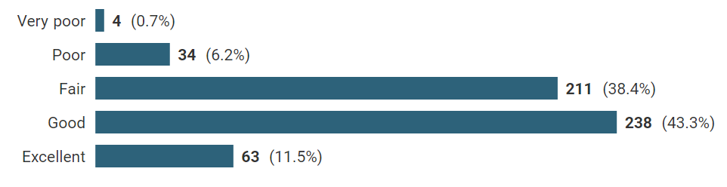

The results are somewhat encouraging, with 55% of respondents rating their basic knowledge of mental health and wellbeing good or excellent and only 7% rating their knowledge as poor or very poor. The split in responses across sectors was similar to the summary results above.

* 1. **Appetite to learn about mental health and wellbeing**

Despite reasonable existing knowledge about mental health and wellbeing as shown in the previous question, 73% of respondents indicated they would like to learn more about mental health and wellbeing. The highest interest was from the Third Sector (79%) and Health Care (78%) and lowest interest from Police (57%).

This may reflect a gap between people developing knowledge and feeling confident to put it into practice. Or it may be the workforce are looking for different knowledge to what they already have. Further work may be required to understand this better and what requirements there are to fulfil this identified need. The results to seem to indicate the importance of developing a resource for the wider wellbeing workforce which can facilitate access to information and additional support.

* 1. **Confidence in signposting**

Participants were asked torate how confident they felt in signposting people for more information/support about mental health and wellbeing. This was a more general question around confidence, not specific to a certain topic such as physical activity or financial security as in section 4.2.

Chart 4: Please rate how confident you feel in signposting people about where they can go for more information and/or support about mental health and wellbeing in West Lothian?

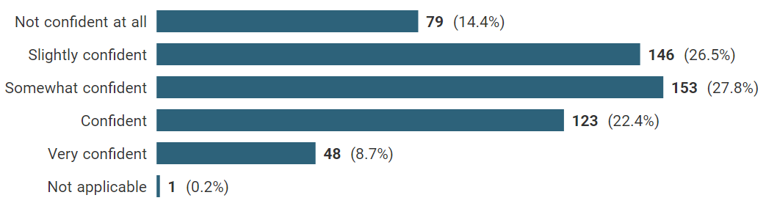

The results show a range of confidence levels in signposting to additional information/support.

Only 31% of respondents reported feeling ‘confident’ or ‘very confident’ in signposting and 14% were not confident at all. There was a spread across all levels of confidence in each sector, highlighting a need across the board for support to increase confidence.

* 1. **Practitioners section on West Space**

Respondents were asked what type of information they would like to see on a new practitioner’s section on the website West Space, to help people feel more informed about basic mental health and wellbeing in their roles.

The following options were included and those highlighted in bold were most popular, with two thirds of respondents selecting ‘all of the above’.

* **Basic mental health awareness**
* **How to support good wellbeing**
* Factors contributing to poor mental health and wellbeing
* **Where to signpost people for more information**
* **Community assets to support wellbeing in West Lothian**
* **Mental health and wellbeing pathways in West Lothian**
* Details of relevant training courses
* Details of relevant events
* **All of the above**
  1. **Mental health and wellbeing learning/support opportunities**

Respondents were also asked what learning and support opportunities would be helpful in relation to mental health and wellbeing.

The following options were included and those highlighted in bold were most popular, with 55% of respondents selecting ‘all of the above’.

* **Information and awareness sessions**
* **An online area containing relevant information/resources**
* An opportunity to network with/meet other practitioners
* **An online directory of support services**
* **An opportunity to hear about local services/supports**
* **Free e-learning on mental health and wellbeing**
* An online space for community discussion
* **All of the above**

1. **West Space Website**
   1. **Awareness of West Space**

Respondents were asked if they were familiar with the website West Space[5], which provides local mental health and wellbeing resources and information. Despite the intention of the website being the ‘go-to’ first port of call for mental health and wellbeing support in West Lothian, there was low awareness and usage as shown below.

Chart 5: Are you familiar with the website West Space?

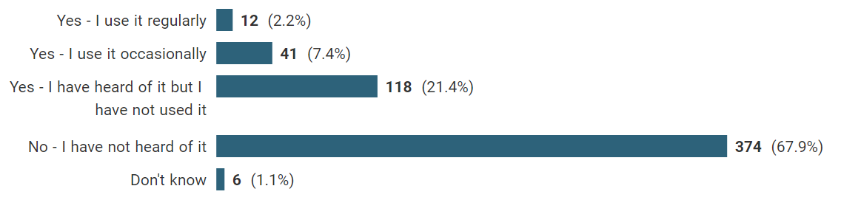

Over two thirds of respondents did not have any awareness of West Space. A further 21% of respondents did have awareness of West Space but had not used it, with only around 10% of respondents overall reporting using the web site regularly or occasionally.

There was variation across sectors in respondents’ awareness and use of West Space. This was highest in the Third Sector, followed by Health Care. A more detailed breakdown by sector is shown in Table 3.[6]

Table 3: Awareness and use of West Space

|  |  |  |
| --- | --- | --- |
|  | **Awareness** | **Use** |
| Voluntary/Third Sector | 55% | 27% |
| Health Care | 44% | 14% |
| West Lothian Council | 31% | 10% |
| Education/School | 21% | 3% |
| Police | 2% | 0% |

* 1. **Usefulness of West Space**

Of those who do use West Space, 63% rated it as ‘useful’ or ‘very useful’ with another 23% rating it ‘somewhat useful’. This highlights that West Space is a useful resource for West Lothian, however there is a lot of work to do to improve awareness.

1. **Conclusions & Recommendations**
   1. **Conclusions**

In conclusion, this results from the West Lothian Wider Wellbeing Workforce Survey suggest there is lots of scope to increase awareness about the 6 Ways to Wellbeing model and provide additional support and resources to support the wider wellbeing workforce’s knowledge, learning and confidence in signposting. There is also an evident need to focus raising awareness of West Space, as this is the platform being used to provide additional support.

* 1. **Recommendations**

The following actions are recommendation as a result of the survey findings and will be taken forward by, or in partnership with, the Adult Mental Health Prevention & Early Intervention Group:

* Share the findings from this report widely with key sectors, including sector leads responsible for workplace wellbeing and training.
* Create an area on West Space to support the wider wellbeing workforce based on the findings from the survey and undertake user testing.
* Consider gathering further insights into the wider wellbeing workforce requirements to inform further developments of the area on West Space.
* Consider if any additional activity is required to support the wider wellbeing workforce with confidence in signposting.
* Undertake online awareness raising sessions to provide a walk-through of the new area on West Space when live.
* Develop a communications plan to increase awareness of West Space in the public and people working in West Lothian (additional resource may be needed to support this activity).

***Report prepared by:*** *Helen Hassall, Population Health Project Manager (West Lothian), NHS Lothian on behalf of the West Lothian Adult Mental Health Prevention & Early Intervention Group December 2023.*

**Appendix 1 – Quotes on opportunities/challenges to improve mental health & wellbeing in West Lothian**

**West Lothian Council**

|  |
| --- |
| *“I feel there is a lot on offer online/over the telephone if you feel up to helping yourself, although I have heard some negative feedback from some of these services and I would be reluctant to use unless desperate.”* |
| *“In terms of improvement, more joint working across services/agencies/less silos; joint training opportunities; remove barriers and manage to share info as appropriate where there is a common customer, tenant, client/user; look at the customer/patient journey as a whole and not as individual org/agency; use a range of communication methods to reach people.”* |

**Education**

|  |
| --- |
| *“There are many services available but they don't tackle the root cause of aspects of mental health (e.g stress) They're just sticking plaster approaches to ease the symptoms of stress without addressing underlying issues and improving wellbeing at work.”* |
| *“As a teacher I sometimes feel that we need more support given the abusive behaviour we encounter on a regular basis.”* |

**Health Care**

|  |
| --- |
| *“We have daily contact with people from the most socially deprived areas of West Lothian who are struggling with all aspects of their mental health. It is multifactorial problem that needs a whole societal approach.”* |
| *“I am a GP - the workload has gone up massively, the pay has gone down, expenses in life have gone up adding additional pressures to life. We are all working with less reserve and less support. we are trying to support our colleagues as everyone bounces toward burnout and are currently managing to pull then back, but it is having a huge cost to all of us in reserve. Honestly, we need more workforce, as the workload has exploded, and this needs to be funded. I have just applied for a mentoring scheme to try to keep me in GP. fingers crossed it works. Otherwise, me, and several of my colleagues will be giving up. Thank you for doing this survey, not sure it will help, just good you are gathering data and trying to help.”* |

**Voluntary Sector**

|  |
| --- |
| *“The organisation I work for promotes numerous wellbeing resources to staff and we have a counselling service available for staff and our families, however due to workload it is not always possible to access these services and sometimes they are not particularly helpful.  More widespread training for everyone would be beneficial in my opinion and more free events encouraging the community to be outside would be a positive thing.”* |

**Police**

|  |
| --- |
| *“I have numerous colleagues who have been off work with mental health related illnesses, the majority of which are caused by the job.”* |

1. This group is the West Lothian Adult Mental Health Prevention & Early Intervention Group.
2. The new Scottish Government Mental Health & Wellbeing Strategy defines the wider mental wellbeing workforce as including wider public, third, and independent sectors which, although not directly employed in providing mental health services, support and treatment, play an important role in supporting someone's mental health and wellbeing and can also play a significant role in promoting good mental health for all. Examples include, but are not limited to, employers; health, social work and social care staff; community link workers; police officers; community group leaders; faith leaders; school staff and youth workers.
3. The menopause was included as its impact on physical activity and mental wellbeing has been highlighted in research published by [SAMH](https://www.samh.org.uk/documents/Academic_Research_Summary_Report_Menopause_mental_wellbeing_and_physical_activity.pdf).
4. 25% of people responded to this question.
5. [West Space](http://www.westspace.org.uk) contains self-help materials, guides and resources and a directory of services based in West Lothian.
6. Other sectors were not included due to low response rates providing unrepresentative percentages.