Third Sector Older People’s Provider Forum
Tuesday 1.30pm Hybrid May 20th

Chair: Graham Stevenson (Home Instead)
Note Taker: Victoria Isbister (VSGWL)

Present: Marcia Moreira, Jamie (50+), Tracy Kerr (VSGWL), Susan Scott (MIST), Leighann Bishop (Xcite), Esther Lynn, Billie Hamilton & Lorna Bryson (OPAL)
Apologies: Ann Edwards (Food Train), Andrea Gourlay (Answer House), Sylvia Forshaw (OPAL), Donna MacKey (Sporting Memories)

- Welcome, apologies, introductions (Chair)
- Previous minutes and outstanding actions: No comments on last action note.
- What’s on Where Directory update:
Graham advised he had sent an email today regarding Summer edition which is due out start of June. Please confirm any amendments by Tuesday May 27th. Graham can update spreadsheet on your behalf. Does anyone want featured in an article – this can focus on a topic or a piece of work? Brochure will incorporate Home Instead new branding. Graham will update when printed copies are available. Spotlight: Spark: event first weekend in August.
- VSGWL Update (Tracy)
Service locator was launched April 1st and work continues to update this. New membership offer for Orgs, corporate rate for members of staff with Xcite. Quite a lot of take up on this which has been great. Volunteer Awards event on June 6th, WLVN hope to hold event later in year. Nominations are in and a panel will now meet to decide winners. Tracy holding one to one sessions with Tracy about funding: May, June, July. Future training events inc Naloxone: 2 Mondays in June. All information in our newsletter and socials. Question surrounding additional information on service locator – Tracy advised that we are working on additional resource now that student has finished placement at the Gateway.
Events from 9 June – 23 June
Membership - Voluntary Sector Gateway West Lothian
- Service updates (all members)
OPAL:
- Focus on volunteer week and holding mixture of 3 events: information stall outside hub showcasing volunteer opportunities, thank you event and coffee morning with chief executive. Coffee mornings in hub been slow recently, could be the good weather?
- COWL are running information session this week.
- Young at Heart launched in partnership with Xcite, free event 1.30-3.30pm Wednesday. Thank you so much to Leighann for securing funding - new posters are being printed with confirmed dates.
- New project with Mood and the Bridge inc financial advisor based in office once a month in the community space. Also, two free workshops, Spend Less Eat Well: budgeting and recipes then make lunch and enjoy a meal together. Will circulate once dates confirmed.
- Still transitioning groups from staff led to volunteer led.
- Resource library available for all – games and activities free of charge. On the right-hand side as you go in, list of what’s there, sign items in and sign out. Activities can be used within the hub, tea and coffee facilities available. Open Mon – Thurs 9-5pm.
50+: Jamie is the new charity manager and working out his role. All groups continuing and in fact expanding: Guitar lessons Monday evenings in June and chair yoga in Bathgate hub on a Monday lunchtime 12.30. Keen to work in partnership with groups and currently in conversation with Broxburn Utd. First Aid course delivered for free June 14th Saturday; 4 places left! Open to staff or volunteers.
Health in Mind: Unfortunately, WL services facing funding challenges, the result of which is 2 services are closing: Peer connecting on May 20th and Ethnic minority service mid – July. There is still some availability for anyone who needs service now as full ten weeks could be fulfilled. Wellbeing workshop provides self-management tools. One to one 50+ service running well, just finished wellbeing toolkit workshop which went wonderfully well and already arranging second one end of June. 3 available spots. Self-referrals.
Health in Mind | Homepage
COWL: Dementia action week seems to be going well, social media buzz. Also facing funding challenge and as a result lost social media and graphic comm designer. Volunteer’s week in June followed by Carers week.
MIST: Memory Information Support Team. Early intervention support service. 155 families registered - from anyone who hasn’t spoken to GP to people on a waiting list. Once diagnosed, support can then continue with core support groups which have been running for a long time.
- New team leader Sheila Neilson in post in older people’s community mental health team.
- Online event well attended, planning next event after summer, hopefully catch people who were missed at last event.
- Noticeable increased need for respite and day centre services, representative of the social care crisis and the different environment we now find ourselves. OPAL agreed with this, adding that they have noticed a shift in referrals reflecting a higher need including phone calls from people considering suicide. What other training could be available to support staff? There are massive waiting lists for Mental Health services and it is particularly hard to apply training when person is on the phone. Susan said in their case management system they have a case complexity tab and this data shows increase in needs. People are at crisis point when they engage. Susan said emails are being sent daily to Adult protection team however it’s taking weeks for carers to get contacted and referrer never hears back. Leighann suggested Andy’s man’s club as have accessed support there a few times.
- Time to Live funding has been received by Scottish gov and will hopefully be available soon for unpaid carers: not sure yet on criteria. Boundaries now in place for Asda vouchers to stop reliance. About CoWL
- Upcoming wellbeing days: dates to be confirmed. Cold water therapy – inundated with interest. Session full, 45 people on a waiting list.
- Parent carer service has just received funding so will grow.
- COWL cards: if you know of any local services / agencies who want to join, please contact Susan. CoWL Card.
Xcite: Ageing well running as well as second month of Young at heart. In first month 16/17 attended, this month 43, which shows information out. Funding also received to deliver holistic approach in Fauldhouse. Different blocks: dates and themes tbc. Chair yoga being delivered Craigwood June 23rd Monday 11.45. 20 spaces by existing yoga instructor.
Reengage: Social isolation and loneliness, age demographic over 75, light touch. Welfare and safeguarding. 1:1 phone calls, social groups, 60th birthday events: overall and groups. Also noted increase in needs, can see the gaps in training and awareness. Love to share events and partner with anyone! Looking for accessible community spaces at weekends, please get in touch: esther.lynn@reengage.org.uk. Parking spaces for drop offs needed.

Home Instead:
- Had increase in out of office calls including suicidal thoughts which is a first.
- Can help with respite, inundated last year, particularly summer. Ongoing or one offs. Meeting a lot of different people, some as a result of event at HPC in March. Uniquely placed to offer continuity of staff including overnight support and live in care, round the clock if needed, someone can be in house 24/7.
- WL college event jobs fair next week.
- Launched Spot the Signs campaign encouraging awareness. Also factors in how these changes can impact on family and carers. Lots of resources available including checklists, all free, please get in touch if you need anything, available digitally also.
- How to approach having a care conversation with someone. Often people don’t have conversation early enough and it comes to crisis point. Hoping to arrange small group events to help people navigate round “the stuck moment”. Office not very accessible so trying to work out better location.
Sporting Memories: “All West Lothian clubs going well, supporting around 40 older people every week. Jamie from WL 50+ Network visiting our Linlithgow club this week. Excited to attend the West Lothian Volunteer Awards on 5th June!“

- West Lothian Council updates: Senior People’s Forum
- Held April 9th: focused on changes in social work, split social work and NHS teams into East and West divisions from June / July. It is hoped this will cut down internal referrals and be more streamlined to people’s needs. Susan spoke about her frustrations following an urgent unsuccessful attempt to speak to social work one day: Contact Us - Health & Social Care Partnership Susan has fed back her concerns to CEO.
- Discussion surrounding purpose – is it for professionals or for older people to have a voice? It is high level and there is no floor for people to have an opportunity to have a say. Tracy advised members have provided feedback in the past inc more notice for the date. seniorpeoplesforum@westlothian.gov.uk
- Eligibility Criteria: Graham said he has seen change in Eligibility criteria in last few months as people not being assessed for the same stages as previously and some are being reassessed and losing their funding. SDS (self-directed support). People are reaching crisis point. Trying to advocate for clients with WL. Very concerned about “Double ups” (where a client requires 2 carers) as council now only providing funding for 1 staff member with mention of putting in equipment. Awaiting further guidance. Liability would lie with provider.

- AOCB
- Rosemount café - Campaigners fighting to save West Lothian care home cafe have just weeks to come up with plans - Daily Record Couple members had heard something about an extension through local Facebook posts.
- Follow up to March event: Home Instead and MIST: Susan said she would definitely like to do another fair however need more people on board to work on factors. Ideas: Themes (e.g. volunteering), change location, frequency (Quarterly?).
Subgroup: OPAL. All welcome.
- Shared : creative breaks programme: https://www.sharedcarescotland.org.uk/short-breaks-fund/creative-breaks/
- Regal Radio – 3 months for £25, charity discount rate
- Funding: Ford: The Ford Britain Trust | Ford UK
- Broxburn coffee morning, 15 carers, partnership COWL
- Virtual dementia carers support group (in person hosted for years), 25-30 people, trial virtual session launched.

Actions
1 What extra support can we provide to staff and volunteers? Welcome to Lifelines Scotland (all members). ANDYSMANCLUB - It's Okay To Talk
2. Article for WOW: all members to Graham
3. Circulate resources: Graham / Victoria
4. Feedback to PDSP / third sector working group regarding care concerns: Tracy
5. Feedback to Emma Gouldie: All members to Graham with any comment
6. Tracy will reach out to SPF based on feedback received: all agreed invite to forum.
7. Event Subgroup – invite SPF in first instance (action 6), otherwise create subgroup

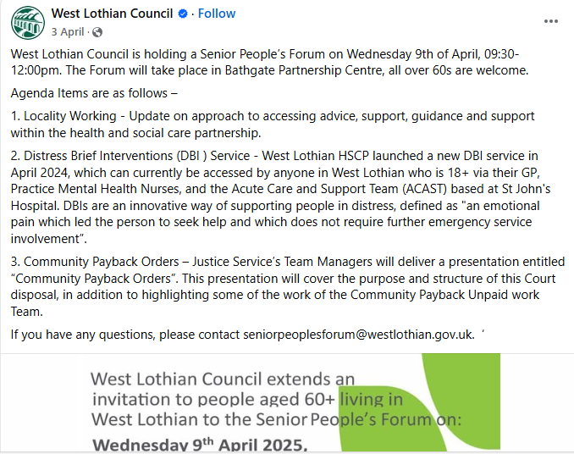

(DBI – please note Third sector can’t refer)

