West Lothian Volunteer Network
February 25th (Tuesday 2pm)

Chair: Linden Raeburn (West Lothian Council) Linden.Raeburn@westlothian.gov.uk
Note Taker: Victoria Isbister (VSGWL) Victoria.Isbister@VSGWL.org
Apologies: Claire Garton (NHS), Elizabeth Campbell (HCL), Carol Tugman (Social Security)
Present: Ray Fallan (VSGWL), Sharon Rae (Cyrenians), Adele Bain (Voiceability), Leighann Bishop (Xcite), Aynsley Douglas (WLC), Dorothy Terhune (NCT), Chris McLaughlin (Active Schools), Jennifer Harley (Team Jak), Roz (School Bank)

- Welcome and Apologies: Linden opened the meeting.

- Guest Speaker: Adele (Voiceability)
Independent charity providing advocacy, 40yrs in UK. 4-5yrs in Lothian. Here to support people ensuring their voices are heard e.g. decisions about their health and wellbeing. Also ensuring people understand their human rights and are clear about decision making processes about things that matter. Active listening, empowering, information, informed decisions and empowered to say what they want. Do not provide counselling.
- Social security Scotland contract: act states that people should be provided an advocate. Will support anyone with a disability (which means different things to different people)/and includes mental health, learning difficulties and disabilities, dementia. They understand clients’ circumstances inc accessibility needs. Self-referral, phone, webchat, online form, email.
- Unpaid carers contract – vital role. At the moment - cared for person must live in Edinburgh (carer living in WL).
- Group advocacy service – anyone can join this session, working collaboratively, shared experiences. Ultimately empowers people. Identify common themes. Connect lived experiences. Break down social barriers. Share coping strategies.
- School placement: Not yet managed this in WL. 5-day work experience. Advocates go into school and offer to 56th and 6th year, empowerment, networking. Support students to develop life and career experiences such as goal setting. Linden said may be able to offer something in this area.
Ray said she had personally used advocacy and found it so beneficial.

- Last minutes and previous actions
Volunteer vacancies form: https://salesforce.123formbuilder.com/form-6733157/volunteer-opportunity-form-new | All members
Continue to share events on WLVN Facebook | Email Victora, Anne H or Linden
Gues speaker suggestions | All members
Sharing best practices about recruitment | All members to email Chris at Active schools with any information, templates or advice

- Volunteer event: June 2025
Linden received an email to MacMillan inbox from Mercure Hotel offering charities and third sector partners free room hire, 7pm – 1am (see below). Criteria: bring 80people and pay for buffet at £12 per head = £960. Options include Sandwiches, pizza, sausage rolls, spring rolls. Optional DJ £300. Could be compromise between formal sit down and casual event. Linden has confirmed that Council would cover £960. WL College would be other option. Same cost. Other location options are discounted due to high cost.
Event could include Awards, presentation of certificates, entertainment (source local talent?. Mid-week date? Evening?



- Volunteer Fayre: June
Volunteer week. Venue preference? Possibilities: St Davids House community space (if open). Howden Park Centre – cost and availability. Could have it in Bathgate partnership centre if no other options.

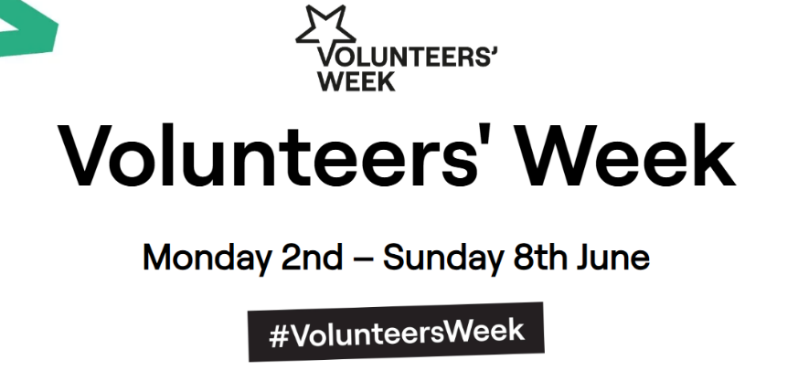

- Service updates inc Volunteer celebrations: awards, successes, stories
NCT: Funding situation means no update at moment. Lothian breastfeeding buddies.
Xcite: No update
Cyrenians: Funding awarded for 2 busses with HCL: Linlithgow and Strathbrock. New men’s group up and running and well attended, every 2nd Wednesday 2-4pm. Community hub accessible – phone up and book. Free resource library – come in and have a look! Sharon finishing with Opal, has been on secondment from Communities, she will still be working in WL, different capacity.
School Bank – Quiet spell over Feb break, volunteer celebration couple Fridays ago at the office: coffee, cake, quizzes and games. Got funding to provide school camp packs. Can now support 29 schools. Schools can help with cost of camp with PEF (Pupil Equity Funding) however a long list of items are needed for camp e.g. Cagoul, boots, sleeping bag. Donation points in Stoneyburn and The Vennie. Visited Polbeth hub today and looking to get one set up there.
WLC Pathways to volunteering – Busy month - planned to run 1 course, ran 2 as there was an ask from adult learning group. 12 people through in last 3 weeks. Now all out on various placements inc Happy Hoofbeats. Next session end of March. Please get in touch if you can offer a volunteer placement opportunity
Team jak: Team Jak - Board, staff and key supporters had a successful team building and training day yesterday. Volunteer training arranged for 11 March. Bee Happy Ball this Saturday at Prestonfield Hotel, annual fundraiser sold out. During mid-term we had extra lunch clubs for children on school holiday. Abseil fund raiser at Falkirk Wheel on 14 March - £25 registration if anyone would like to take part.
Active Schools: Always looking for more volunteers for extracurricular clubs. Feedback was lack of consistent induction so running session March 10th. (see slide below)
VSGWL: PVG Waiver and April 1st new laws (PVG will now be mandatory, for roles working with vulnerable groups) and Disclosure Scotland changes. Brief discussion about the impact on volunteers. Vulnerable group definition list unchanged. Service locator – new website tool will be live from April 1st – easy to use and accurate!

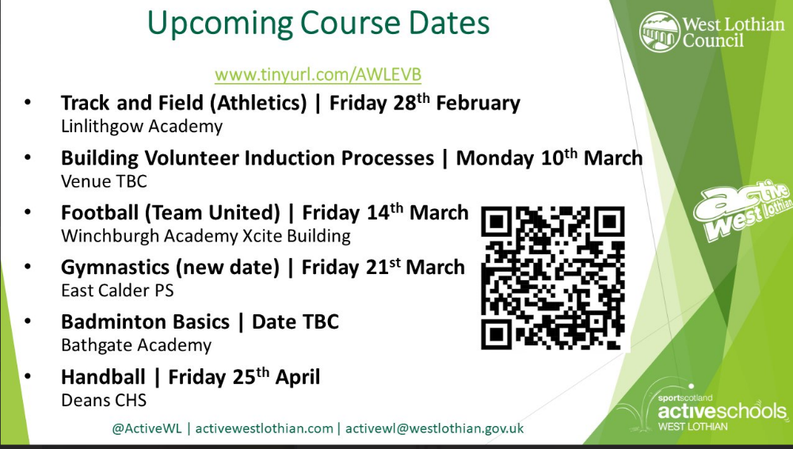

- Any other business
- Volunteer mapping – how many volunteers does WL have? (May Agenda)
- Themed marketing campaign (Lee)
- Get in touch with any guest speaker suggestions (see below). Ray encouraged services to “sign up” to Volunteer charter and spoke about her disappointment surrounding volunteer expenses, even in the face of organizational budgets.
- MacMillan Changes – Due to funding they have reorganised staff team and services being provided - MacMillan buddies no longer exists, free Bupa counselling also gone. Improving the cancer journey still have lots of services to offer.

- Next meeting date – last Tuesday of the month 2pm online

 | Guest Speaker | Themed discussion
January 28th | Dogs trust
February 25th | Voiceability
March 25th |  | Volunteer Expenses (Linden)
April 29th | VSGWL Service Locator (Tracy)
May 27th |  | Training
June 24th | WLC Volunteering (Linden)
August 26th |  | Volunteer Fayre
September 30th | Community Benefits Gateway (VSGWL) | PVG (Ray)
October 28th |  | Volunteer retainment
November 25th |  | Volunteer Scotland?

Actions
- Victoria to email Lee regarding Linlithgow opportunities - completed
- Linden will get availability from Mercure for June event
- Volunteer Fayre locations – open to suggestions from all.
- Partner newsletter Anti-poverty service - aynsley.douglas@westlothian.gov.uk – happy to promote events
- Share PVG slides - Ray
- Linden to email Sylvia about having Volunteer Fayre at Cyrenians community hub

