# West Lothian Alcohol and Drug Partnership Communications Strategy

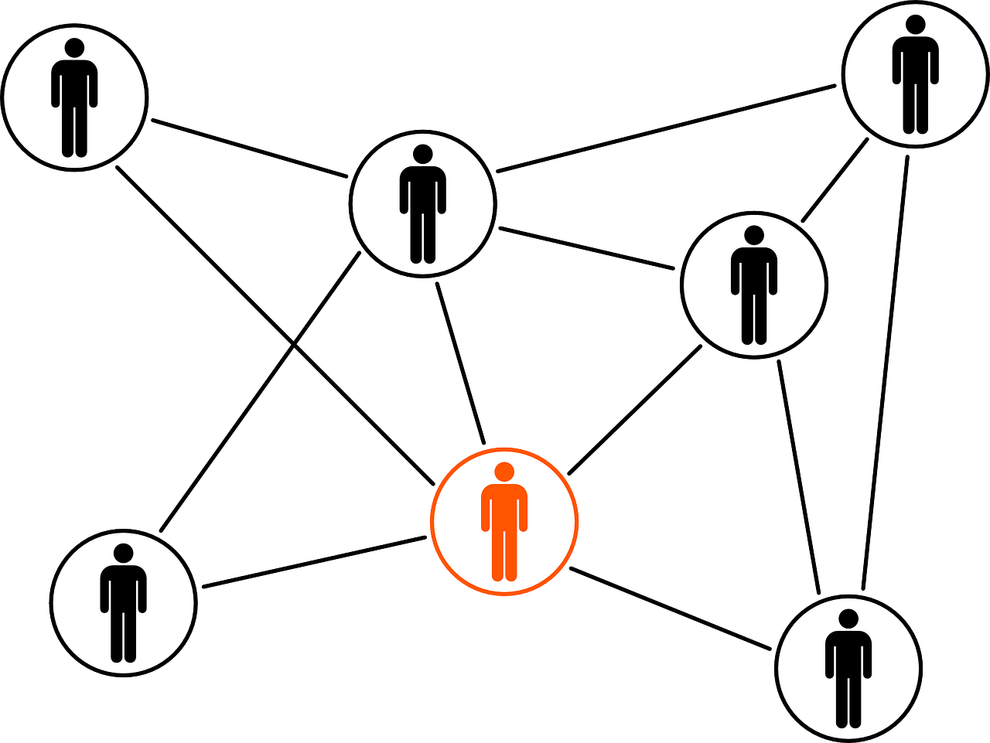

# Easy Read



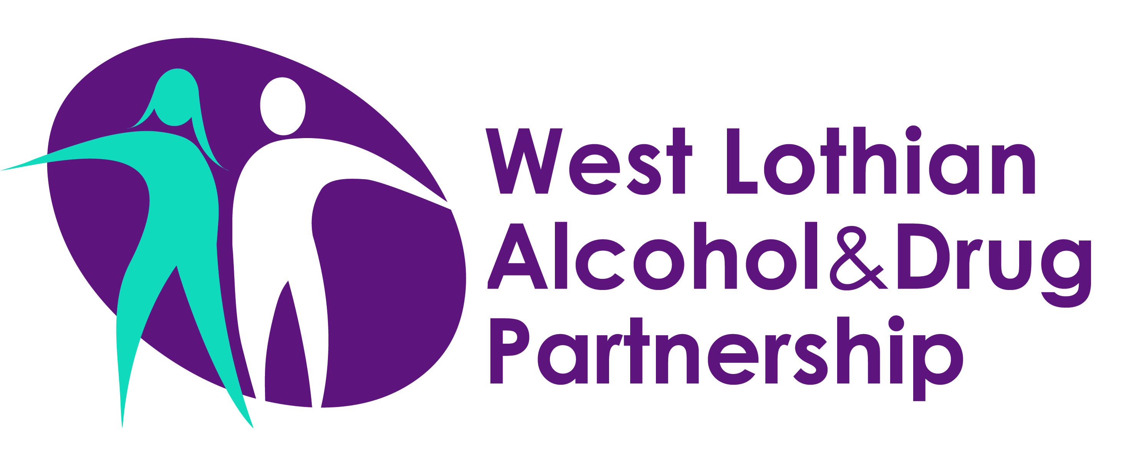

Prepared by West Lothian ADP

**Contents**

|  |  |
| --- | --- |
| Introduction | Page 1 |
| Objectives | Page 10 |
| Objective 1 - Tools & Resources | Page 11 |
| Objective 2 - Inform | Page 12 |
| Objective 3 - Involve | Page 14 |

## 

## Introduction

|  |  |
| --- | --- |
|  | The West Lothian Alcohol and Drug Partnership is a local partnership made up of different organisations who are responsible for reducing harm from alcohol and drugs. |
|  | The West Lothian Alcohol and Drug Partnership has a Delivery Plan in place for 2024 to 2028. |
|  | The Delivery Plan has seven priority areas:   * Priority 1 – Rights and Inclusion * Priority 2 – Prevention and Early Intervention * Priority 3 – Recovery-Oriented System of Care: Treatment * Priority 4 – Recovery-Oriented System of Care: Recovery * Priority 5 – Whole Family Approach * Priority 6 – Public Health Approach to Justice * Priority 7 – Enabling Actions |
|  | This Communications Strategy helps progress tasks in the Delivery Plan, including Priority 7, Objective 9 which focuses on information sharing. |
|  | There are two key target audiences for this Communications Strategy:   * West Lothian residents, including people who use alcohol and drugs and their families * Staff who work in and around local alcohol and drug services |
|  | This Communications Strategy has been developed in consultation with the target audiences. |
|  | Human-rights based tools have also been used to develop this Communications Strategy. They are:   * AAAQ Framework * PANEL Principles * FAIR Model |
|  | Article 12 of the International Covenant on Economic, Social and Cultural Rights makes each person a ‘rights-bearer’ with the right to health. |
|  | The right to health is known as the ‘TripleAAAQ Framework’:   * Availability * Accessibility * Acceptability * Quality |
|  | Public authorities have a legal duty as ‘duty bearers’ to protect and fulfil the right to health. This applies to all staff who work in alcohol and drug services. |
|  | Having a Communications Strategy for the West Lothian Alcohol and Drug Partnership is an important part of protecting the right to health, by making sure the right information is available to the right people at the right time. |
|  | The PANEL Principles are the common way of understanding a human-rights based approach. They are connected and meant to be applied as a whole:   * Participation – people should be involved in decisions that affect them * Accountability – people who are responsible for delivering services and support should be held to account * Non-Discrimination * Empowerment – everyone should know and understand their rights and the rights of people they support * Legality – these rights are based on national and international laws |
|  | This Communications Strategy has been developed using the PANEL Principles, to make sure it follows a human-rights based approach. |
|  | The FAIR Model is another tool which helps apply the principles of human rights to specific pieces of work. It has also been used to develop this Communications Strategy:   * Facts * Analyse rights * Identify responsibilities * Review |
|  | **Facts –**  People who use local alcohol and drug services have told us that communication is a big challenge. |
|  | **Analyse rights –**  As well as the right to health (Article 12, ICESCR), this Communications Strategy is also relevant to the following rights:   * Non-discrimination and equality (Article 2 - ICESCR, Article 26 – International Covenant on Civil and Political Rights [ICCPR]) * Privacy and Confidentiality (Article 17 – ICCPR) * Information (Article 19 – ICCPR, Article 15 – ICESCR) * Participation in public affairs and decision-making (ICCPR Article 25, with links to United Nations Declaration on the Rights of Indigenous People [UNDRIP] and Disability Rights Framework * United Nations Convention on the Rights of the Child (UNCRC) Article 3 (best interests of the child); Article 24 (right to health information) and Article 33 (protection from drug and alcohol harms) |
|  | **Identify responsibilities –**  This Strategy has a Tracker with actions, which is managed by the ADP Support Team. |
|  | **Review –**  This plan will be reviewed in 12 months and an annual report will be produced based on how much progress has been made against the actions in the Tracker. |

## 

## Objectives

|  |  |
| --- | --- |
|  | The overarching aim of this Communications Strategy is to develop tools and resources to inform and involve staff and the local community – including those in treatment and recovery – in updates and information about the West Lothian ADP. |
|  | This will be achieved via three main objectives:   * Objective 1 – Tools & Resources * Objective 2 – Inform * Objective 3 – Involve |

## Objective 1 – Tools & Resources

|  |  |
| --- | --- |
|  | Objective 1 of this strategy focuses on developing a range of tools and linking to existing resources to keep staff and the local community informed about:   * What services are available and how to access them * The role and function of the Alcohol and Drug Partnership * Updates including case studies, statistics and other relevant information |

## Objective 2 - Inform

|  |  |
| --- | --- |
|  | Objective 2 focuses on making sure that staff and the public can access accurate information and updates about the Alcohol and Drug Partnership, as well as national and local tools and resources. |
|  | This includes digital and non-digital ways of sharing information. |
|  | Examples of how this will be done include:   * Researching to find out what happens in other areas and using best practice * Checking that all existing information about the Alcohol and Drug Partnership is accurate and up to date * Thinking about how to reach groups who are less heard, such as those from protected characteristic groups * Having a publicly visible and easy to use Alcohol and Drug Partnership Complaints Process * Having an ADP Mailing List to keep people up to date |

## Objective 3 – Involve

|  |  |
| --- | --- |
|  | Objective 3 is about involving staff and the local community, including those who use drugs and alcohol or are in treatment/recovery, in the development and carrying out of this strategy. |
|  | The consultation around this strategy consisted of:   * Getting views from those who attend local Recovery Cafes in Blackburn and Livingston * A digital consultation process with staff and partners via MS Forms * Staff and partner engagement in Alcohol and Drug Partnership meetings * Signed-off by the Alcohol and Drug Partnership Executive Board |
|  | As well as involving people in creating this strategy, it is important they are involved in carrying it out too.  Ways that staff and public are involved in carrying out this strategy include:   * Offering members of the public the chance to attend Alcohol and Drug Partnership meetings * Various feedback methods including staff/public surveys * Any other evidence-based ideas that come out of any feedback people provide |
|  | If you have any comments or questions about this strategy please contact the West Lothian Alcohol and Drug Partnership via email – [wladp@westlothian.gov.uk](mailto:wladp@westlothian.gov.uk) |