Third Sector Forum: Children and Families
Tuesday May 19th at 1pm, Stadium House
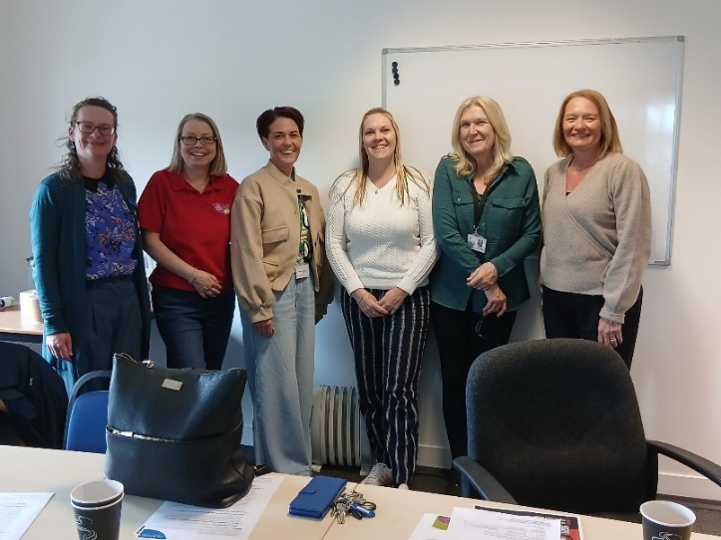
Present: Tracy Kerr and Victoria Isbister (VSGWL), Helen Davis (WLYAP), Fiona Brown and Folke Wiemann (WLDAS), Simon Henderson (Play Works), Paul (Aid & Abet, Project Sol), Charlene Boyd (WLC), Collette Moran (School Bank), Hazel Tyson and Alison (Circle), Wilma Murray (COWL)
Apologies: Catriona Ross (The Larder), Daisy Drop In, Gareth McKenna (BUSC), Craig Paterson (CAB), Tracy Clusker (WLDAS), Caroline Millar (Children first), Tess Hamilton (Cyrenians), Zoe Brown (NSPCC), Angela Douglas (Play Works)

- Welcome and Apologies
Helen offered those present a tour as would welcome groups getting in touch if they would like to use the space. Will be promoting hire over the summer. Small cost charge to cover electricity. 7 days a week.

- Agency Presentation: Grief matters (WLDAS): folke.wiemann@wldas.org
- Grief therapy with young people between 12 and 18yrs who experience sudden or unexpected bereavement (doesn’t need to be substance related)
- See presentation: What are the sessions for, what happens in sessions, referral process and information on bereavement in young people inc grief models.
- How many referrals? Around 25 since August 2025. 140 parental consultations in 3 years / 79 young people supported prior. Folke’s caseload around 9. Referrals: From Education mainly and CAMHS. Self-referral over 16 years. Is there anything in school curriculum regarding grief: varying awareness between schools. Tends to be pupil support awareness of service.

- Action note from March 17th actions and matters arising: Passed.

- Feedback from other meetings
- Children & Families Strategic Planning group meeting: Children and Families services plan progressing, important that all services have opportunities to feed in. Could have an in-person meeting next year to gather feedback? Could also be useful for the annual report. Simon requested input from all members to ensure fair representation of third sector. Action all Demands on the third sector are high. Can we build in time here to discuss C&F strategic planning group Agenda? Action VI Discussion around benefits and logistics of in person meetings. Action TK Important to discuss how we are represented and work together.
- Alcohol Drug Partnership: Review Whole Family Approach report completed by Figure 8 consultancy has useful information which could support funding applications. Short timescales of funding remain major issue to services. Report shows value of working with families and engaging parents rather than solely young people in isolation.
- Community Safety group: Environmental health staffing concern. Police and Fire service no longer present – which is missed. Action SH
- Mental Health oversight group: Children Rights Network event June 10th Howden Park AM. Event last week at Bathgate partnership centre was well attended. We know children and young people have ideas - how do we get them involved and capture opinions. Helen spoke about recent semi unplanned outdoor event success – will try more of this.
- Food Network: Full network meeting June 3rd. Train the Trainer session date confirmed for September.
- Social Enterprise: Met April 22nd. Study visits have been useful - discussed how to work together: competing for funding, importance of partnerships, where are the gaps? Contact Raymond.branton@vsgwl.org if you want to discuss. Funders like collaborative bids. SE event May 2027.
- Climate Action Group: News - West Lothian Climate Action Network
- Child Poverty Steering Group: No update
- In work poverty update (CAB / April): No update

- The Promise: No update on PIP advocates.

- Whole Family Wellbeing Fund
Ends March 2027. Frustration at finding suitable date for meetings. Importance of reporting back on the great work being done with funding – which also potentially lays groundwork for future funding.

- Voluntary Sector Gateway West Lothian
- Third Sector Strategy Group - Voluntary Sector Gateway West Lothian
- Victoria completed Green Champion training last week about found it really useful Business Energy Scotland · Make your business greener
- Celebrating Volunteers event June 4^{th:} delighted with number of nominations.
- Volunteer opportunities showcase went really well: also useful for The Gateway as highlighted opportunities we were unaware of.

- Members updates
- School bank: About to launch summer campaign for August, 50% of referrals come in Summer holidays. Who We Are - SchoolBank Funding for pre-school through nurseries: casual wear: helped 125 kids last year. Some schools have hubs thanks to WLCAN and Edin Airport funding, trying to be creative and as widely available as possible.

- 2026 meetings – online only / in person / hybrid
May 19th | In person only, WLYAP
July 21st | Hybrid, The Gateway | TessHamilton@cyrenians.scot  Confirmed VI 19.02  Scottish mediation confirmed 23.04  WL Flames confirmed 25.03
September 22nd | In person only, School Bank | Collette confirmed VI 19.05
November 17th | Hybrid, The Gateway
January |  | Children & Families Strategic Planning group Agenda
March |  | Children and Families Annual report

Actions
- Children & Families Strategic Planning group: Get in touch if there’s anything you would like raised: All
- C&FSPG: Request in person meeting – TK/AMC (TSWG?)
- C&FSPG: Build in time to discuss feedback for agenda: Sept 22nd VI
- Feedback at third sector working group SH

Room Hire - Voluntary Sector Gateway West Lothian
Sign up to our e-bulletin - Voluntary Sector Gateway West Lothian
Home | West Lothian 4 Community (Funding tool)

