Third Sector Employability Forum
Thursday April 30th at 1.30pm: In person at The Larder
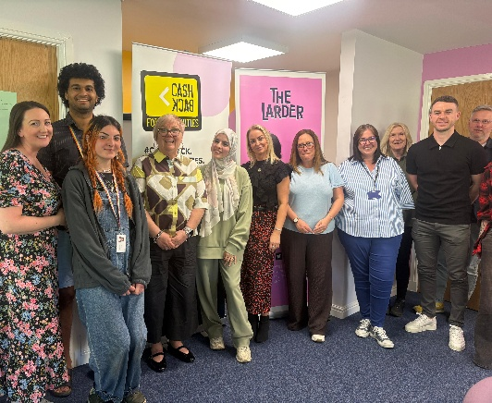
Chair: Liyan Adnan (VSGWL)
Present: Victoria Isbister (VSGWL), Simon Henderson (Playworks), Tracy Murdoch (Kidzeco), Hayley Gillies and Angela Moohan (The Larder), Louise Crozier (CAB), Fin Russell (Impact Arts), Alia Davies (Cyrenians), Adam Brown (Street League), Steph Bryce (Partnership for Parents), Jane Deary (Almond Enterprises), Helen Davies (WLYAP)
Apologies: June Dickson (Environmental Health CIC), Gareth McKenna (BUSC), Alan McCloskey (VSGWL), Claire Stewart (WLC), Electra McPhillips (Firefly)

- Welcome, Apologies and Introductions
Liyan opened the meeting and thanked The Larder for hosting inc lovely refreshments.

- Previous minutes: Actions and matters arising reviewed (all completed)

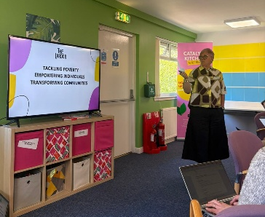
- Guest speaker: Angela Moohan: The Larder
Angela Moohan provided an overview of the work of The Larder, including their training and employability programmes which support individuals across different stages of the employability pipeline. The discussion highlighted the value of locally rooted, place-based approaches that allow services to remain flexible and responsive to community need.

- Council / LEP updates (Liyan)
Updates were shared regarding the Local Employability Partnership (LEP), including:
- The 2026/27 LEP Investment Plan has been submitted to the Scottish Government.
- Alexa has taken on the Employability Manager role on a six-month secondment.
- Third sector investment remains in place, with further information expected following committee reporting in June.
- Increased reporting requirements linked to Helix and Scottish Government monitoring were noted.
- Members were encouraged to engage with the Practitioners Employability Partnership (PEP) as an additional route for practitioner voice and collaboration.

Action LA – Share LEP AIP and PEP meeting dates - Explore opportunities to learn from LEP approaches in other areas
Forum members discussed the importance of:
- Meaningful third sector involvement in employability planning and strategy development.
- Improved opportunities for communication and information sharing ahead of LEP discussions.
- Continued collaboration across the employability landscape.
- Recognising the different stages of the employability journey and supporting organisations to better understand local gaps, overlaps, and partnership opportunities.

- Review TSEF MOU

Members reviewed the role and purpose of the Third Sector Employability Forum (TSEF), including how the forum can better contribute to and influence the LEP.

Discussion focused on:

- The importance of timely information sharing ahead of LEP meetings to support meaningful third sector input.
- Strengthening the collective third sector voice within local employability discussions.
- Improving communication, partnership working, and the sharing of information across the employability landscape.
- Developing a clearer shared vision and future direction for the forum.
- Ensuring the forum remains inclusive and supportive for organisations with different levels of employability knowledge and experience.
- Members also discussed learning from approaches used in other LEP areas and exploring future strategic development opportunities for the forum.
- good_commissioning_principles_and_practice.pdf

- Service Updates
The Larder: New service launching in August: The Life programme: young adults with additional support needs – at their request. (Information Circulated 29.04 VI). Will be advertising vacancies.
Impact Arts: Monday June 15th West Calder community hub: next phase!
Street league: Have 2 spaces, Xcite Bathgate, 9 weeks, started Monday.

- AOCB

Partnership Discussion Session

Members were reminded of the upcoming partnership discussion meeting taking place on 13 May at Voluntary Sector Gateway West Lothian.

Employability Directory Development

An update was shared on the development of the West Lothian Employability Directory, which aims to support both practitioners and the public by improving visibility of local employability services and opportunities.

Actions
- Share LEP Improvement Plan once available. (LA)
- Explore opportunities to learn from employability partnership approaches in other areas.
- Share upcoming PEP meeting dates with forum members. (LA)
- Arrange a future strategy session to review the forum MOU and future direction. (VL)
- Invite LEP representatives to attend a future forum discussion following the strategy session. (VL)

