Third Sector Mental Health Forum
Tuesday June 9th 2.15pm *Hybrid*

Chair: June Dickson (Environmental Health CIC)
Note Taker: Victoria Isbister (VSGWL)
Present: Mark Vance (WLDAS), Ann Taylor (CAB), Julie Ellam (Health in Mind), Anna Taylor (Health in Mind, WestSpace), Karen Campbell (MH Advocacy project), Lauren McDonaugh (The Larder), Tracy Murdoch (Kidzeco), Sami Cormack (WLDAS)
Apologies: Tracy Kerr and Alan McCloskey (VSGWL), Jen Kennedy (50+), Donna Paterson-Harvie (Neil’s Hugs), Maria Throp (1st Step), Lyndsey Wood (NHS)

- Welcome, apologies, introductions: June opened the meeting and gave guest speaker apologies (technical issues!).


- Previous minutes April 1st: agree, actions: Agreed – post on website.
- Explore different TSI’s as guest speakers – Tracy (completed)

- Guest speaker: Lyndsey Wood, Team leader, East community MH team: Event in October at The Brock, 10-2pm. Please follow on Facebook: WL MHWB Network. A central hub to share news and services. Need help promoting event. Would like to involve young people / schools and get funding to provide lunch for stallholders. June and Mark have attended in previous years and recommend. June added that it’s good for people looking for services as well as an opportunity for organisations to check in with colleagues. Highly recommend.

- Mapping exercise
- Services: Definitions, Categories. Find gaps. Share resources.
- How to share information - Padlet (potential for later), Teams (rejected)
- Julie exploring how to host something West Space | Mental Health and Wellbeing West Lothian
- NHS directory: ALISS - A Local Information System for Scotland | ALISS
- Homepage - West Lothian Locator

- VSGWL: Victoria completed Green Champion and found it really useful Business Energy Scotland · Make your business greener. Tracy is planning a networking event with a football theme Tuesday June 23rd 4-6pm. As a condition of funding, all projects awarded money from Communities mental health and wellbeing fund have listed their services on West Space. Successful event last week celebrating volunteers in West Lothian.

- Service updates
Environmental Health CIC: Starting new session of funded places from CMHWB fund and have trained as wellbeing coaches – more information to follow.
WLDAS: In final year of partnership for wraparound services with Circle and WLYAP funded by CORRA (ends Aug 27) so exploring other funding avenues. Family Matters project helped and supported family members but ended March 31st due to funding. Recovery week September 21st- 25t including event at Livingston Stadium: stalls, walk, soccer aid. Successful award from Communities Mental Health Wellbeing Fund for Mental Health matters project – Sami in post as a result. Currently designing and developing a 12-month programme: 90min group sessions for over 50s in isolated areas inc Addiewell, Stoneyburn, West Calder about Mental Health (MH) Wellbeing (WB). MH vs MH conditions and diagnosis, stigma, how to look after your own MHWB. What is MHWB? Coping tools. Signposting. Education not intervention.
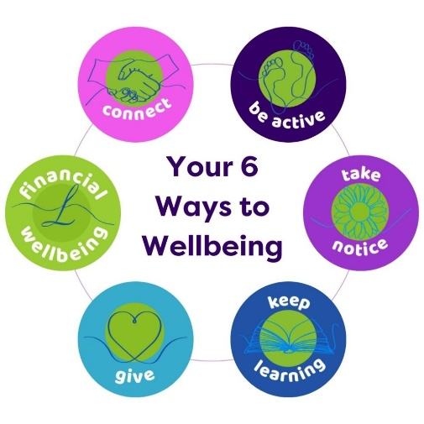
Kidzeco: Thanks to CMHWB funding continuing to run bumps to babies programme, perinatal mental health / pregnancy to age 2. Share coping strategies, information and advice to make the parental journey a bit easier. Peer support, living life to the full and outreach in Whitburn.
CAB: July 1st Gambling support phone line: can refer to MH services.
Health In mind: Scotland’s veteran wellbeing alliance: West Space | New wellbeing hub for Scottish veterans and families
West Space | Six ways to wellbeing. Developing practitioners area: resources and information.
The Larder: Various programmes and partnerships

- AOCB
- Chairperson rota (action for all): Development opportunity plus shares workload!

- Meeting dates
- August 4th online only 9.30am: Anna Taylor: Health in Mind (West Space)
- October 6th Hybrid 2pm: Karen (MH Advocacy Project)
- December 8th online only 10am (Diane Stewart, Suicide prevention)

Actions
- Guest speaker ideas: How best to evidence our impact – invite evaluation support Scotland. Statutory invites – also can showcase what the TS are doing.
- Get in touch to chair a future meeting

Links
Room Hire - Voluntary Sector Gateway West Lothian
Sign up to our e-bulletin - Voluntary Sector Gateway West Lothian
Home | West Lothian 4 Community (Funding)
Homepage - West Lothian Locator
https://salesforce.123formbuilder.com/form-6733157/volunteer-opportunity-form-new

