Third Sector Positive Ageing Services Forum
Tuesday 2.30pm – 4pm in person, April 21st, 2026
In person: Answer House, Reveston Lane, Whitburn, EH7 8HJ
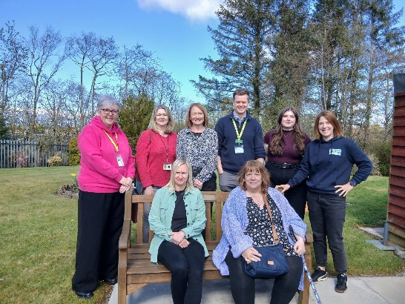
Chair: Andrea Gourlay
Note Taker: Victoria Isbister (VSGWL)
Present: Tracy Kerr (VSGWL), Sylvia Forshaw (Cyrenians), Donna MacKey (Sporting memories), Leighann Bishop (Xcite), Graham Stevenson (Home Instead), Alex McKenzie (LIL), Karen Strang (EARS). Apologies: Pauline Moffat (Cyrenians), Rachel Nelson (Fauldhouse), Emma Stuart Jones (Emmas Dance), Jamie Seery (50+), Ann Edwards (Food Train)

- Welcome, apologies, introductions: Andrea opened the meeting.

- Previous minutes and outstanding actions
- Circulate training link TK (Completed)
- Share information RN (Completed)
- Senior people’s forum: No update on dates.
- Invite Rob Allen: TK contacted but no confirmation received of meeting attendance.

- Guest Speaker: Andrea, Answer House
Building purpose built 20 years ago for users with dementia. Now also offer support to people with physical and mental health difficulties. Open 4 days a week, 14 users per day (most attend 2 days per week). When funding allows have entertainment. 4 volunteers collect people who need transport. 9am Tea coffee toast. 10am seated exercise. 11am tea coffee biscuits and activity e.g crafts (anniversary celebrations in June, users helping decorate banner for front of building). 12noon lunch: 2 course soup and hot meal, activity then tea coffee home baking. Use outside areas, weather dependent. Home 2pm. 6 part time staff and volunteers. Provide valuable respite for carers. Room hire inc kitchen available. Referrals through social work or GP. Good relationship with Armadale academy - one student wasn’t sure what to do and has now decided to pursue social care. Intergenerational work with primary schools including Pinewood.

- Guest speaker: Alex, Lothian Centre for Inclusive Living (LCiL), peer support and learning team
Alex thanked forum for invite. Disabled persons organisation, based in Edinburgh, offering range of services to independent living. Choice dignity and control. Peer support sessions include short presentation on a variety of topics related to social care. Valuable service - important to have space to share lived experiences. Can be a positive way to use potentially negative experiences in an isolating and challenging time. Support and understanding can be invaluable. Space aside from family support.
Group of lived experience volunteers, peer facilitators, community ambassadors. Worked with social work students at Napier - role play useful to illustrate to students how little things can be impactful (such as being late for an appointment). Also work with Living streets in Edinburgh.
Range of services: independent living (self-directed support 1:1 support process), recruitment, employer responsibility. Disability advice and information service (Grapevine). Event April 29th at The Gateway. Ideal pathway, Peer support then onto independent living. Discussion in the group and agreement about the value.

- What’s on Where Directory Spring update
Graham suggested due to timing skip Spring guide and bring Summer edition closer. Group was agreeable and thanked Graham for efforts. Article and updates, contact Graham. Guides are starting to find their way into different areas in the communities. Group of volunteers via Whitburn CDT took 3 last year and distributed which was brilliant. Action GS
Whats On Where | Home Instead West Lothian (Livingston)

- VSGWL Update (Tracy)
- Events from 21 April – 4 June
- Online Volunteer recruitment event: Pairing up volunteers and 8 organisations. May 6th. Volunteer Opportunities Showcase Event - Voluntary Sector Gateway West Lothian
- Green Skills Champion: Green Champion Training (Free CPD Session) - Voluntary Sector Gateway West Lothian
- Grants of £10k-£20k available - closing date is 28 April
https://asdafoundation.org/our-grants/local-community-spaces-fund/
- Year 6 Community Mental Health and Wellbeing Fund confirmed.

- Service updates (all members)
Food train: Food Train have been busy as usual with service delivery. Our friends trips are continuing and proving to be popular. We have been working on service promotion for all services and have been out in the community. If anyone is interested in having us come along please give us a shout.
Cyrenians OPAL: Lost 25% in funding so focus on fundraising. Team and staff did collection Livingston Stadium Easter Sunday raised £400. Nutrition course successful. Musical event end of May in Linlithgow. Trauma informed practice next week – there is a space please contact Sylvia if interested. In person in Bathgate.
Xcite: Ageing well classes running. Weekly walk in partnership with Whitburn CDT, starts and ends at the garden. Open day next Wednesday, hoping for some engagement. Would like to run outdoor sessions, weather dependent! May 13th event supporting healthy ageing together. Information stalls, seated exercise. If you want a stall, contact Leighann.
Home instead: Big recruitment drive due to increased capacity. Award Winning Home Care, Your Way | Home Instead
Sporting memories: Looking for volunteers for new club at Whitburn CDT, Tuesday mornings. 10.30-12noon. Intergenerational work linking in with commonwealth games in Glasgow. Capturing memories around sport. https://replaymemorymakers.com/
EARS: New Ceo starts end of April. Working through referrals, waiting list for community work. A lot of work around adult protection. Statutory referrals have priority through social work. Interesting work and fulfilling to help people by advocating.
Answer house: Working on getting batteries in for solar panel. Extractor fans in the hub – hot in the summer, cold in the winter.
Access our Community Benefit Gateway | National Services Scotland
- AOCB: none
- Meeting Dates
Tracy asked for feedback: “Nice to get out and about and see people face to face.” / “Great to get people in.” / “Shows off your venue.” It was noted that 2 people had asked for online link.
Date | Chair | Location / speaker
June 23rd | Graham Stevenson (Home Instead) | The Gateway *Online only*
August 18th | Leighann (Xcite) In person only | Xcite / Leighann
October 20th | Susan Scott (MIST) | The Gateway
December 8th | Donna Mackey (Sporting Memories) | The Gateway / Napier student?

Actions
- Invite Rob Allen - TK
- Circulate Summer WOW spreadsheet: GS (completed)

- Senior people’s forum date - TK
