Third Sector Strategy Group Forum
Thursday June 11th 1.30pm – 3pm *Hybrid* The Gateway
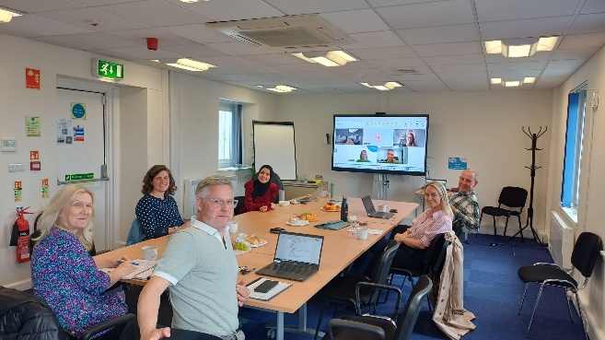
Present: Alan McCloskey, Liyan Adnan, Tracy Kerr, Victoria Isbister (VSGWL), Simon Henderson (Play Works), Jocelyn Lockart (WLCAN), Helen Davis (WLYAP), Angela Melvin (Young Women), David Macdonald (Whitburn CDT)
Apologies: Collette Moran (School Bank), June Dickson (Environmental Health CIC), Gareth McKenna (BUSC), Tracy Murdoch (Kidzeco), Angela Moohan (The Larder), Struan Gard (Xcite), Jane Masters (Play Works), Electra McPhillips (Firefly Arts), Mark Vance (WLDAS), Kathleen (WL Foodbank), Karen Campbell (MHAP).

- Action note from previous meeting, actions, matters arising: No issues.

- Agency Presentation: Lothian Deaf Counselling Service (Beth McLean)
- Covers various hearing loss conditions. Based in Leith.
- 20 sessions of weekly sessions – no cost
- Health in Mind | Lothian Deaf Counselling Service
- Waiting list – 8 or 9 people currently. Can self-refer.
- Recently funded Counselling service for people who were impacted by historic adoption practices – shorter waiting list: Health in Mind | Historic Adoption Peer Support
- Tracy signposted VSGWL service locator: Add/Edit Your Entry - West Lothian Locator

- Council / Sector working group updates and discussion on ideas / plans
- Third Sector Annual report – thanks particularly to David and Raymond. Focus this year on social enterprise. Next year’s report will feature CDT’s.

- VSGWL report
- Mental Health and Wellbeing Fund: Confirmation from Scottish Government (SG) for Year 6. Organisations awarded for 2 years do not need to reapply, just complete evaluation report. Guidance to follow for small grant applications (40-50k) from September 8th. SG intimating likelihood of Year 7 fund.
- Volunteer event: Very successful, emotional – tears and cheers. Every volunteer got a certificate from Moira Niven. Sponsorship made a big difference this year and we are in planning for next year!
- Fairer Futures partnership: SG money being allocated to 10 TSIs – West Lothian is one. Visit to GCVS to discuss what this may look like.
- Will run independent workshops and sessions in Autumn about how to improve and strengthen existing structures. Will share plan once known.
- Networking event: June 23rd: 4-6pm: Football theme: all welcome!
- Developing Partnership and collaboration: Liyan (Employability officer) and Raymond (SE officer) are working on a plan.

- Forum / Sector updates
- WL Food Network (Alan): June 3rd
- Train the trainer sessions booked end of September, reps to be confirmed. Venue is The Larder. Ray is at Forth Valley MP session today about eradicating Child poverty. Guest Speaker: WLCAN.
- Social Enterprise (Alan): April 22nd
- Discussed Partnership and consortia, third sector annual report, what an event might look like and had a guest speaker from WL College about Metapreneur programme. Meeting in 2 weeks at Firefly Arts.
- Employability forum (Liyan): April 30th at The Larder
- In April Forum decided they wanted a strategy session to reflect on TSEF purpose and membership – this was held this morning. LEP now meeting quarterly.
- WL Volunteer Network (Victoria): June 9th
- Lots of positive stories and appreciation from all services about volunteer week. Discussed different ways of matching volunteers with opportunities.
- Positive Ageing Forum (Tracy): April 21st Answer House
- Great to see Answer House (day centre in Whitburn). Members got a lot out of meeting in person. Guest speaker LCiL.
- Children and Families (Helen): May 19th at Stadium House
- Children and Services plan feedback. Scheduled in meeting themes next year to allow for constructive input. Benefits to holistic approach of working with whole family / Alcohol Drug Partnership, importance of preventative work. Guest speaker: WLDAS Grief Matters.
- WL Climate Action Network (Jocelyn)
- Annual Gathering in April: 5 sisters zoo speaker. New development worker Wendy. Gathering June 24th to look at National Lottery Food Systems Fund. Active travel forum July 27th.
- Community planning (CPP): Alan added that he had attended CPP and shared that focus was on climate change and carbon reduction. Local Authority has a tool to calculate carbon however WLC hasn’t published this yet. Update from college on their estate and challenge managing old buildings. Presentation from Danish climate action group about what West Lothian could be doing. Joceleyn said they are planning session in August for developers. Linlithgow CDT spoke about tool library.
- CDT Forum (David)
- Finalised TOR, values and plan. Invited Alan along to see how VSGWL can support. Next meeting July. Not aware of any other forums across Scotland so pilot approach.
- WL Race Forum – no update
- PDSP reps’ updates
Community Safety: Environmental Health risks. Missing police reports.
Environmental: Journey hubs. Missed meeting on 9th as timing change but aware discussed local heat and energy, Polkemmet mine water surveys, Council running 2 allotments, biodiversity groups
Economy: Main discussion WL local development plan resubmission – planning and travellers, infrastructure as result of new building. Questions were asked around Third Sector community fund. Local investment Plan was presented and passed.
Corporate: Report from working group around a framework and mutual agreement for travelling communities. Council Performance for Q3 scrutinised. Horizon scan – always worth read to get an excellent overview of the national and global economic environment indicators. Finance Support report. Sickness Absence Report – WLC has 93.27% attendance. Stress and Anxiety having a strong effect on absenteeism. Council Policy updated for Family Care Purposes with new employment law with updates to Neonatal policy. Highlighted things like Carer leave and parent support.
Education: need new PDSP rep.
Social Work: Item 5 covered WL regulated care provision and the Care Inspectorate grades and contract monitoring structures. Item 6: Adult Support & Protection Awareness Day 2026. Local activity included a social media campaign and an online learning event attended by 68 practitioners. Good evidence of multi-agency learning and third sector involvement. Item 7: HSCP shared their consultation response: Right to Breaks & timescales for support plans for unpaid carers. Councillors asked about consultation with unpaid carers, which CoWL is doing, whereas the HSCP completed the feedback from the perspective of the LA. Item 8: External residential care for children. Item 9: National review of group-based child sexual abuse & exploitation.

- AOCB
- Young Women: Just wanted to say hi and thanks for the invitation. I'm Ange Melvin the Programmes Lead at The Young Women's Movement. We work both nationally and, in a place-based way to delivery funded programmes, research and leadership opportunities for young women 16yrs+. Please feel free to contact me directly if you would like to have a chat after this meeting: angela@youngwomenscot.org
- CAB: Gambling support helpline, launches July 1st, SG funded
- Issue raised on number of forums sit: look at how people engage, reflect on purpose. Guest speaker slots / focus. Mapping exercise on council structures and TSI – abbreviations can be confusing. Who sits where. Networking ask by sector however balanced by resources. Tangible actions and how we influence decision making. Members talked about the value of the meetings noting it’s same attendance. How do we reach others?
- Play works: Business and fair work minister visit today

- Meeting Dates and locations
July 30th – Play Works | September 24th – The Gateway: strategy session | November 26th - TBC
- Any member who wishes to act as PDSP deputy please get in touch
- Any member wishing anything shared, please email Victoria.
- Funding tool: Home | West Lothian 4 Community
- Home - Voluntary Sector Gateway West Lothian

Policy Development Scrutiny Panels (PDSP) - Voluntary Sector Gateway West Lothian
PDSP | Rep | Org | Dates
Corporate policy and resources | Stuart Barrie | VSGWL | April 17th | June 19th | August 21st
Education |  |  | April 14th | June 19th | August 21st
Housing Services | Silence Chihuri | FJSS | April 23rd | June 9th | August 13th
Public and Community Safety | Helen Davis | WLYAP | April 21st | June 23rd | August 25th
Social Work & Health | Mike Niles | Carers of WL | April 16th | June 4th | August 20th
Environment and Sustainability | Jocelyn Lockhart | WLCAN | April 21st | June 9th | September 8th
Economy Empowerment and Wealth building | Alan McCloskey | VSGWL | March 9th | June 9th | September 8th

Actions
- Refresh PDSP reps and processes – VSGWL
- Reflect on forum structure – Tracy
- Share acronym document - Victoria / Liyan

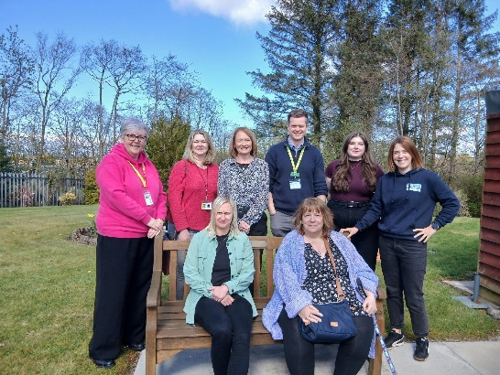
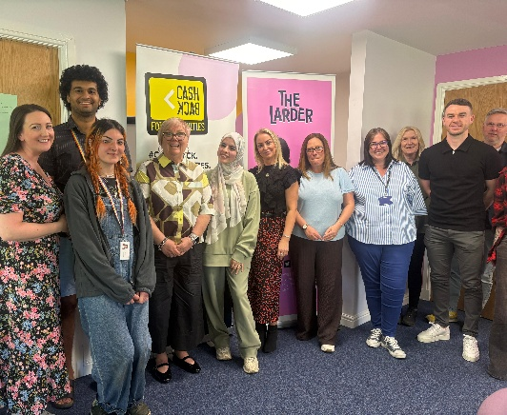
Employability forum Positive Ageing Service Forum

Children and Families Forum
