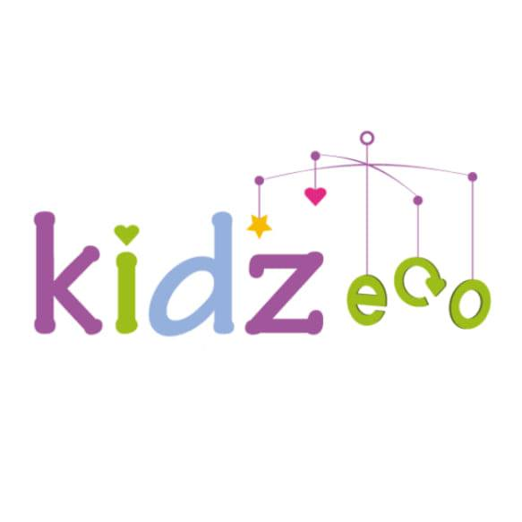
EcoFamiliez Partner Activity Registration Form

Whitburn EcoFamiliez Open Day
Whitburn Community Centre | Saturday 26 September | 1:30–5:00pm

About the Day

We’re inviting local organisations to help us create a fun, family-friendly Eco Day in West Lothian. You can get involved by bringing an information stand, running an interactive activity, or delivering a hands-on workshop or demonstration that celebrates the environment and the brilliant services you offer.

We’re aiming for a lively mix of stalls, activities and workshops throughout the day that inspire families and encourage them to take part. If you’d like to be involved, please complete the form below and email it to maria.martinez@kidzeco.net

Organisation:

Main Contact Name:

Email & Contact Info for the day:

Would you like to have an information stall at the event? (We highly encourage all participants to have an interactive element or mini activity for families)

Would you like to run a workshop at the event? (Describe what participants will do, what they'll learn and whether they'll make something to take home.)

Recommended Age Range
______________________________________________________________

Approximate Session Length
______________________________________________________________

Maximum Number of Families
______________________________________________________________

Space / Equipment Required
______________________________________________________________

Will your activity run continuously or at set times?
______________________________________________________________

Anything else we should know?
______________________________________________________________

What Happens Next?

Once we receive your form we will:
• Review your activity.
• Slot workshops into the event timetable.
• Contact you to confirm your session time.
• Send final event information and joining instructions

